Attribute Menu

# Game Plan

Attributes show: Primaries, Secondaries, Vital on bars

+ Button for Primary, so that we can increase the primary when level up; the secondary will increase automatically with inherited values via modifiers.

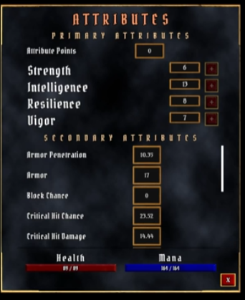

Will require some design thought.

* Values are show with own frame so there’s a widget we can reuse
* FN to set value of numerical data represented
* Rows with text and framed value for each attribute
* Own widget
* Primaries are similar but also have button
* Row widget + Own widget for widget
* Reuse functionality from 2ndary?
* One big widget for menu itself
* How to construct?
* Not all 2nd attributes shown
* Scrollbar to move down to see additional values

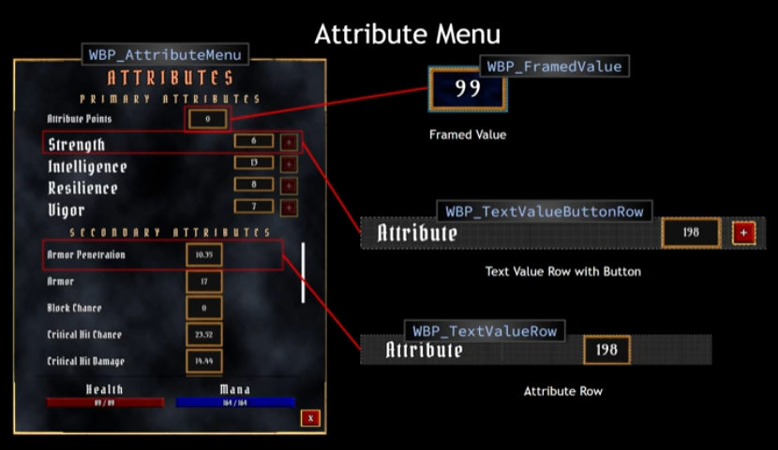

So:

* Framed Value widget for numbers
* Row widget contains text box and also framed value widget
* Primary is a row widget with and additional button widget
* Attribute menu widget contains many row widgets and scrollbar
* Health and mana own widget progress bars
* Close menu widget

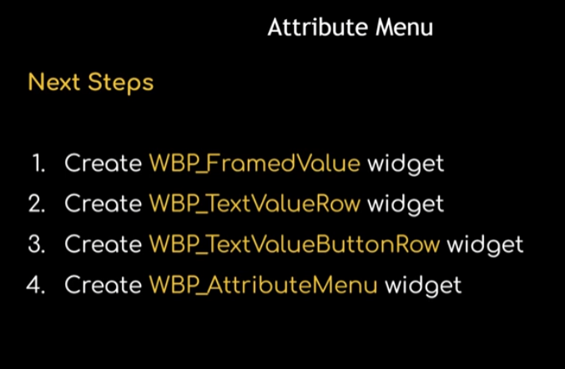

# Framed Value

New UI BP

Attribute menu an Overlay? New folder is tidier

WBP_FramedValue based on AuraUserWidget

+SizeBox

FillScreen to Desired

Override Height and Width to arbirary values 80/45 to work with for now, change later if needed

Box Size (rename to Box Size Root) set to variable; in Graph set Height and Width of box as variable floats

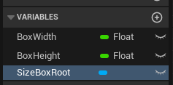

Set category for W + H

Drag in Size Box Root and call set overrides from Event PreConstruct

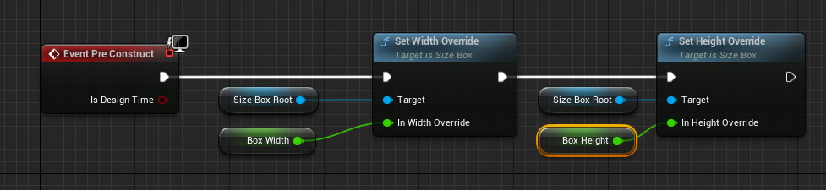

Check defaults, currently at zero and collapse to Function

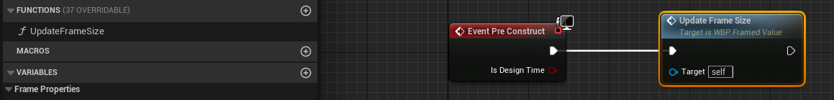

Size box now exists. To add to the menu:

* Background colour/image
* Border
* Text

Since things are going to be on top of one another will need to add an overlay that is a child of the size frame and set to fill it

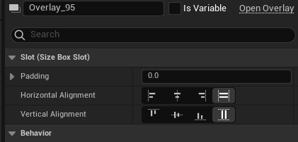

Add an image of a child of the overlay, give it a value, either plain black RBG sliders or an asset:

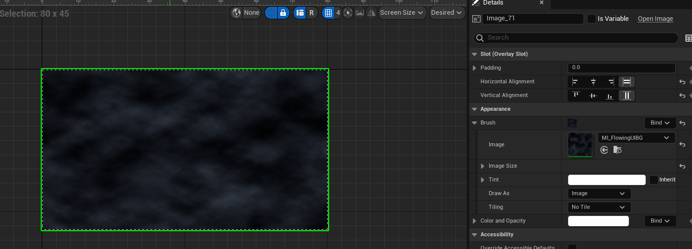

This is an animated asset like the health/mana globes and has params we can set to preference:

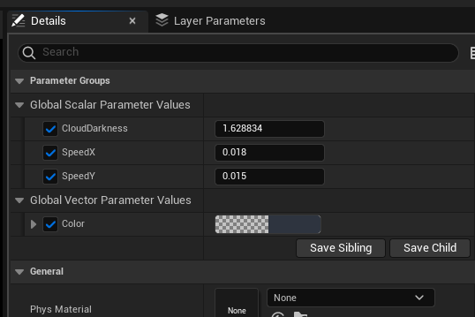

Renamed the new elements and set as variable, then set in the graph:

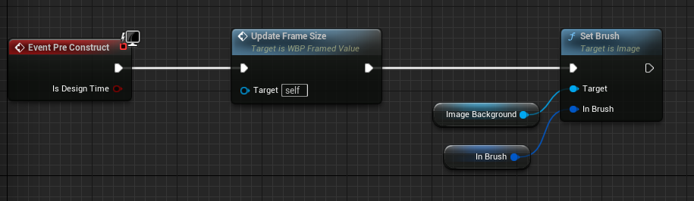

Remember to set a default value for the brush

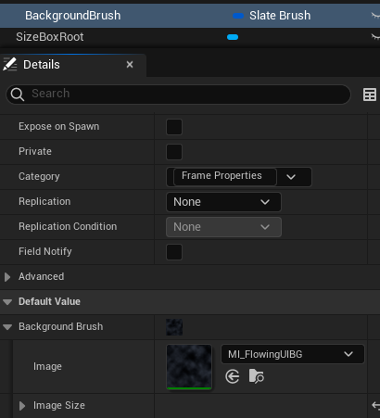

This way we can set variations, like colour, in child BPs if we want

Collapse to Fn

Add new image for the border

Fill H + V

For image pick desired border asset

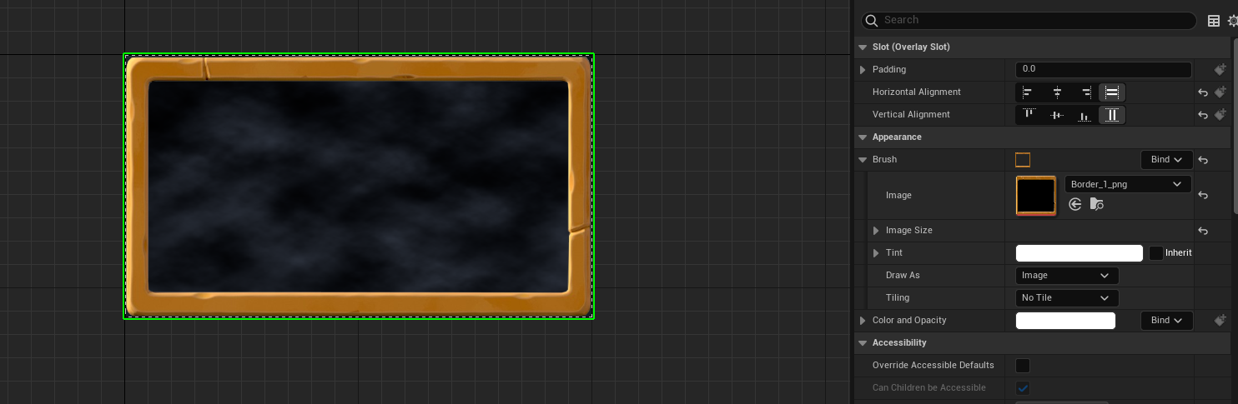

Change Draw As from Image to Border and choose margin size – I went with 0.5 for all.

The size box can be changed in size and the border and background will stretch to match

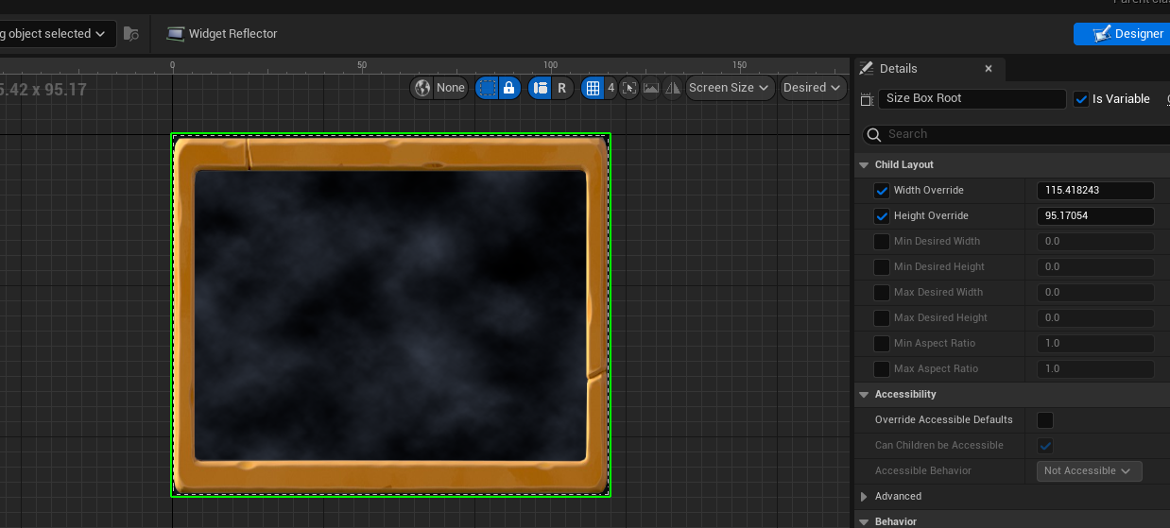

For now I won’t parameterise the border, we can always change that later if we want!

Add Text block. Will set default as a 2 digit number for convenience

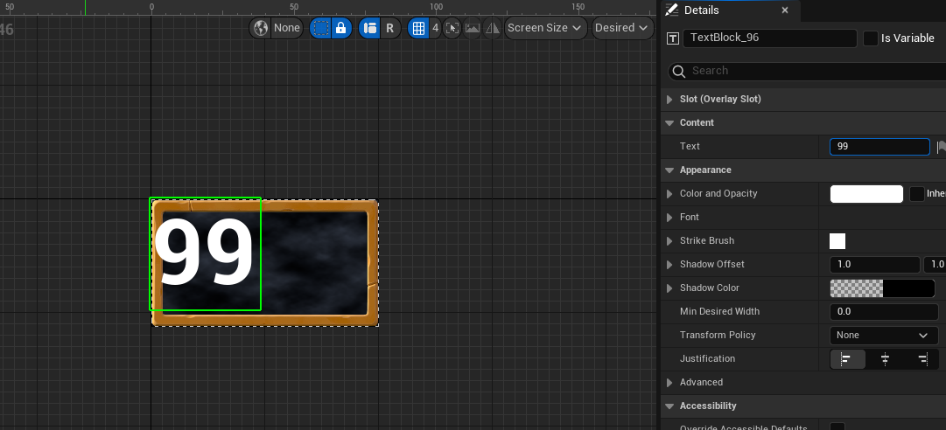

Set alignment (centre)

Set Justification (center)

Change font

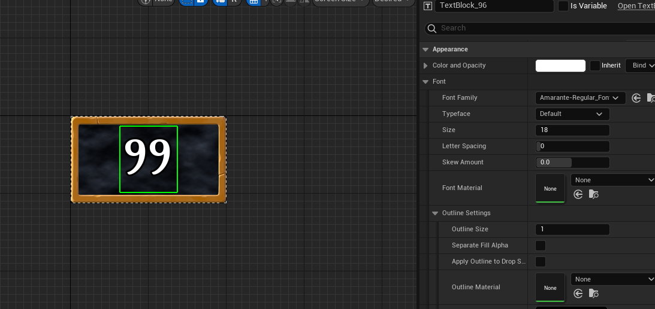

Play with font size and outline settings for appearance

Set the text as a variable so we can set the value with Fn later

# Text Value Row

New Widget WBP_TextValueRow

Add Sizebox, override W and H, as before with the frame

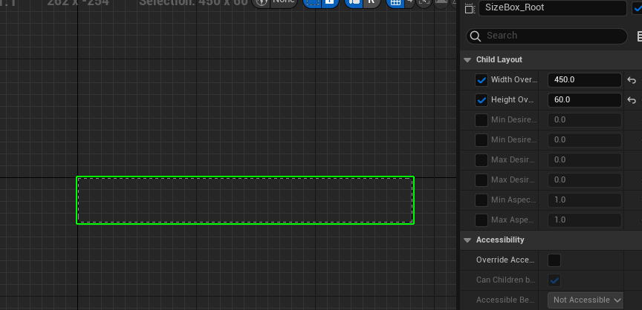

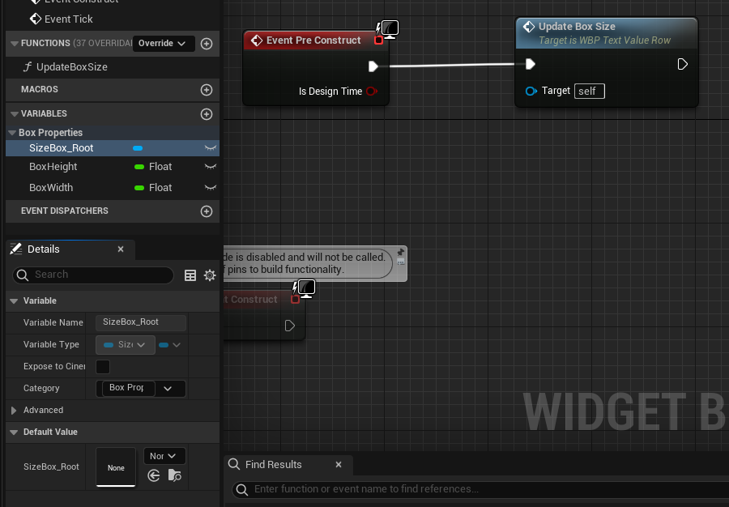

We’ll add elements left to right; first text, then the framed value widget

Add Horizontal Box and text to that box, horizonal align left, centre vertical

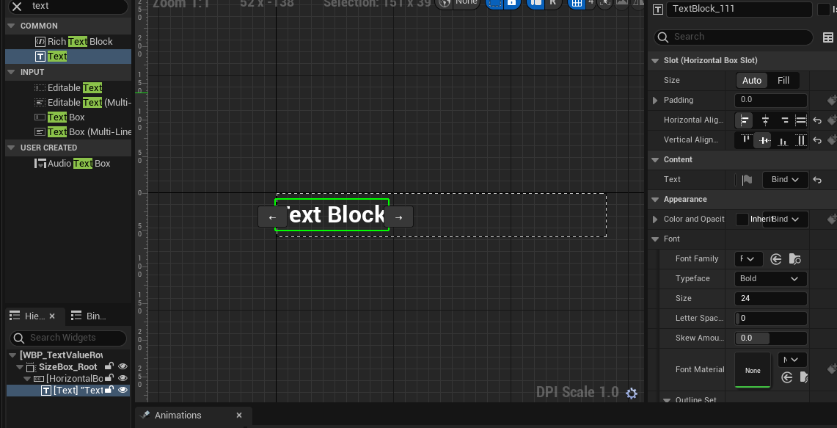

Set default text, font, fontsize outline and fontspacing to taste

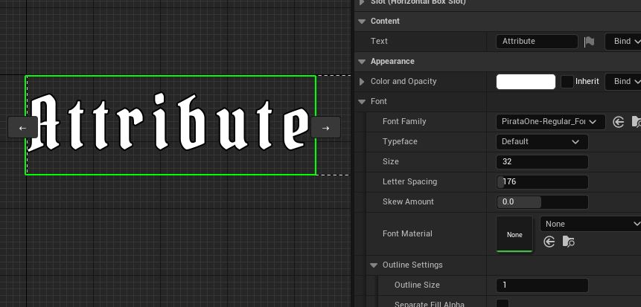

Add FramedValue Widget, set to fill, right, center

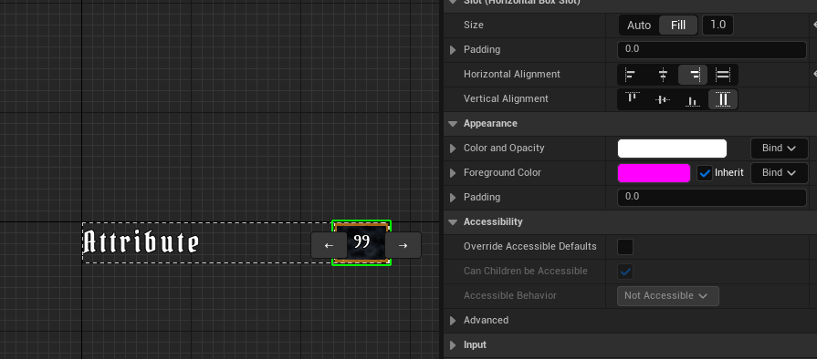

Add a spacer after it to modify the size a little

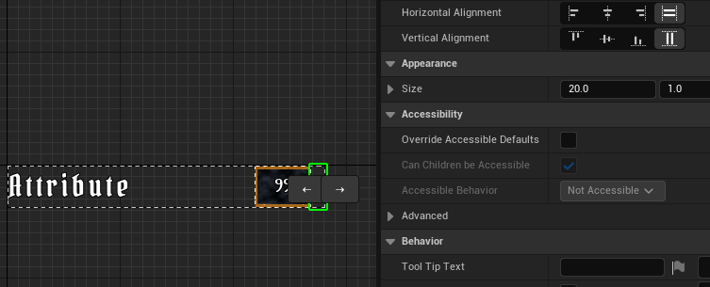

Test with longest attribute names (intelligence, critical hit resistance)

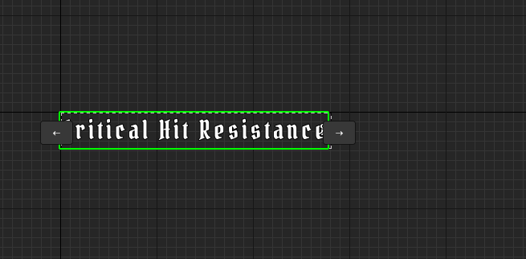

Too long! Make the size box bigger!

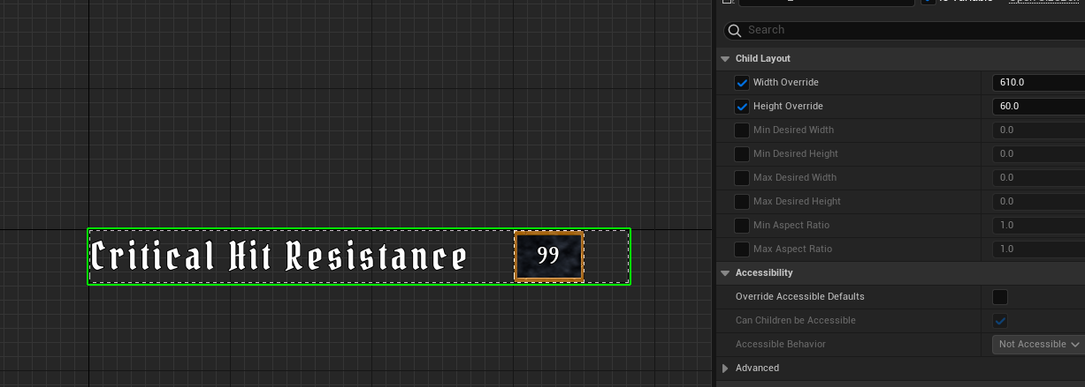

Better!

The spacer works well, but remember we will also need to add a button in a child class

For this we can add a Named Slot

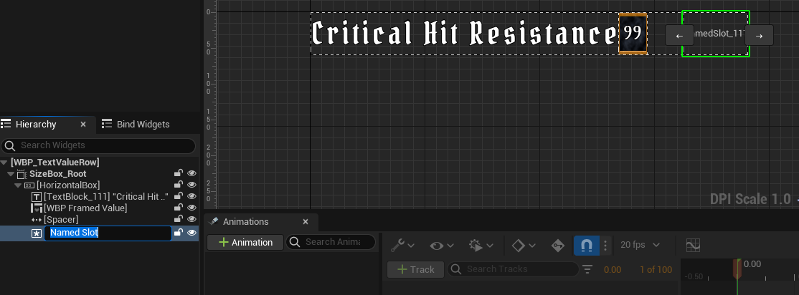

Slot will allow children to have more widgets on the named slot

Tinker a little for overall taste:

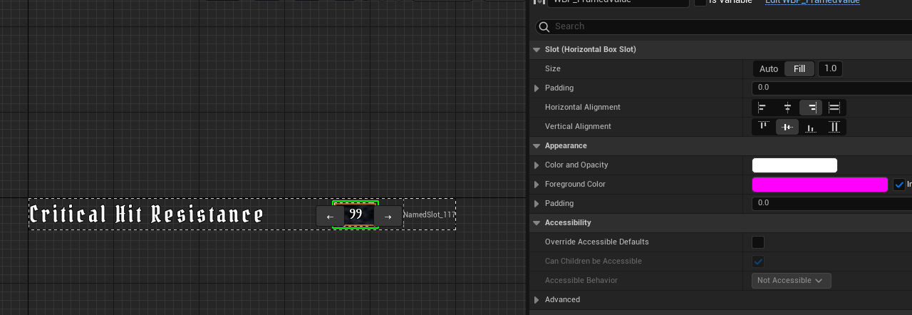

# Text Value Button Row

New widget based on the Text Value row

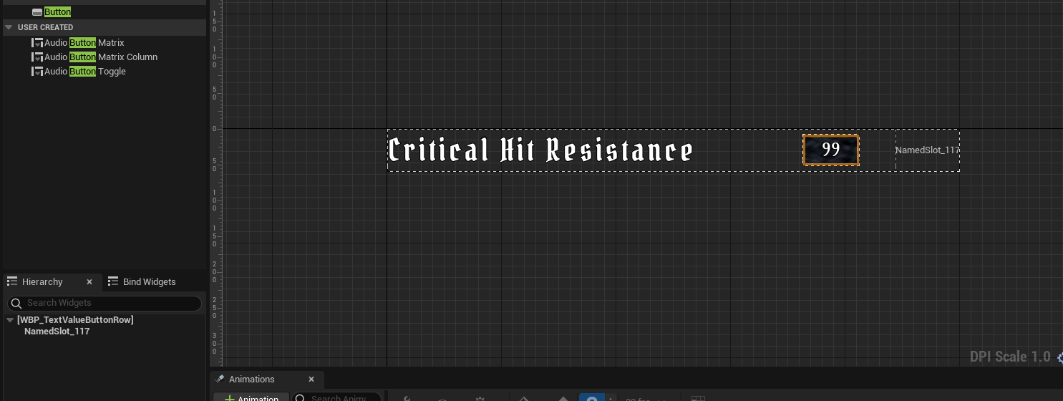

Includes all elements by default but only the named slot is accessible.

However, we will need to change the text and the numerical value for each instantiation, so we need to expose them!

For now, let’s add the button. Start with an overlay and an image for the button border/background

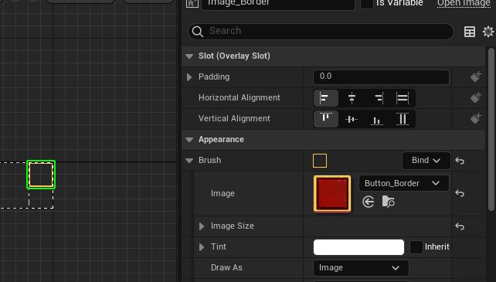

Center and draw as image, set size (I picked 45 * 45 to match the value box size)

Add button

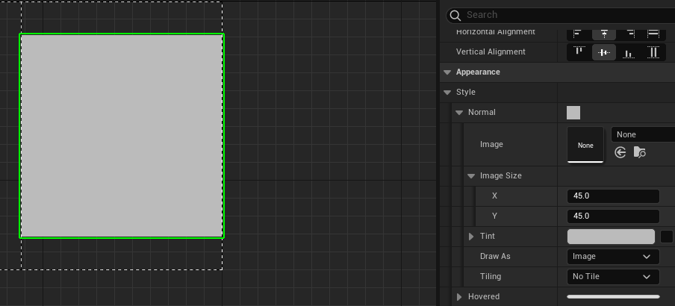

Now pick styles for Normal, Hovered, Pressed and Disabled

This project has existing assets to use out of the box

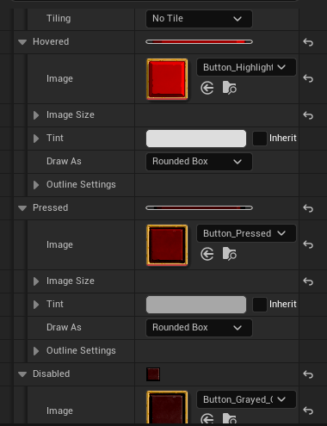

(set to draw as image)

We can add a single character of text, a +, so we know it’s for adding to the attribute!

Alight and justify as usual, set a font and appearance to taste

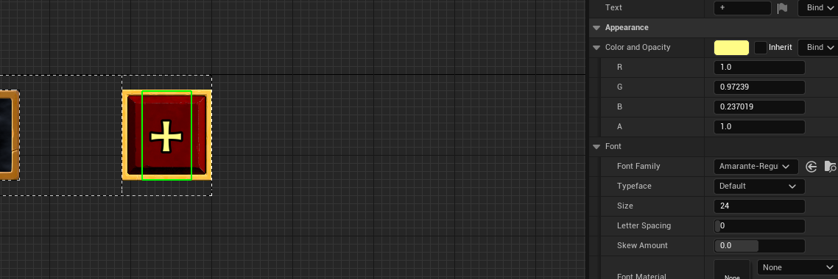

We’ll need functions to set text and numerical value and make the button functional

# Attribute Menu Construction

We now have 3 widgets to use in the attribute menu

As before, sizebox/overlay - for now hard code widgth/height as this is a specific object

Now we start stacking.

We want a border, title, value widgets for rows with buttons etc

Draw as border, 0.5 borders etc

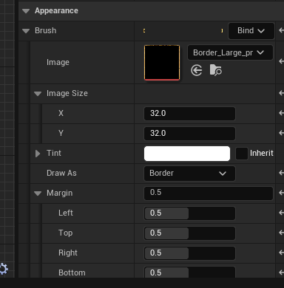

Add a wrap box to help space and align things properly

We’ll drag the elements onto the wrap box

Text block for manu name:

ATTRIBUTES, Fill space, set a size, centered Horizontally

Give wrap box a padding

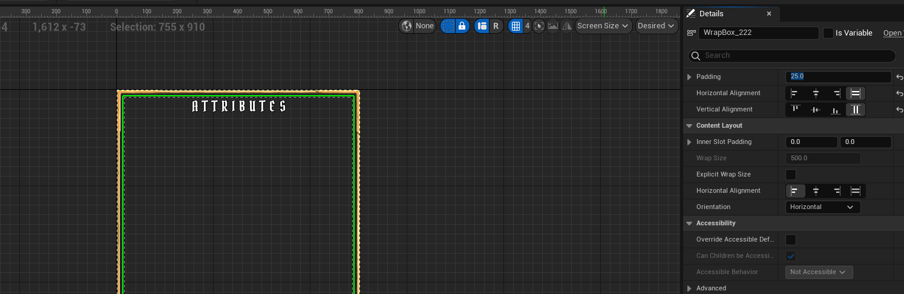

Adding fields

Wrap box will wrap to a new line if over size, example:

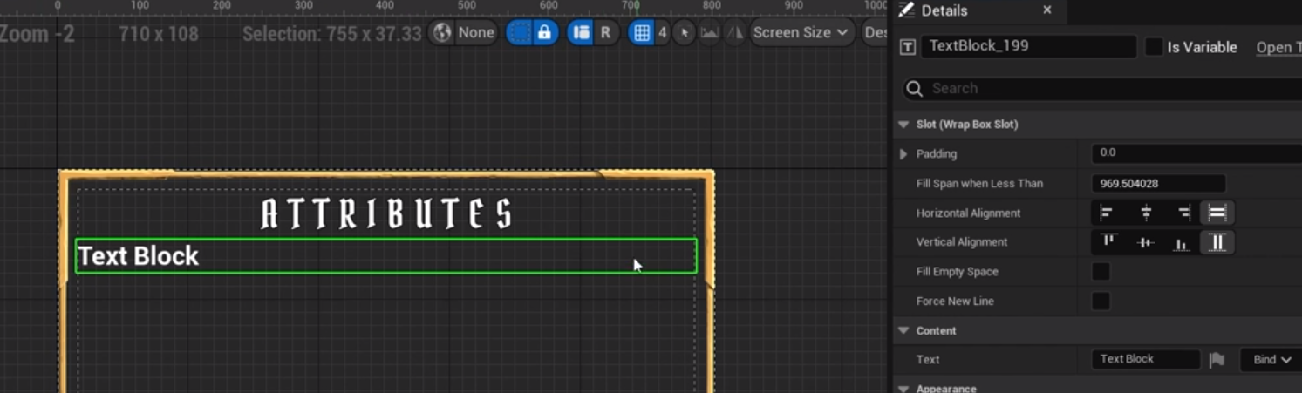

Setting the new text box here, which starts right after the other box, to on “Fill span when less than “with a value greater than the set size of the sizebox, will result in the text box being pushed to a new line

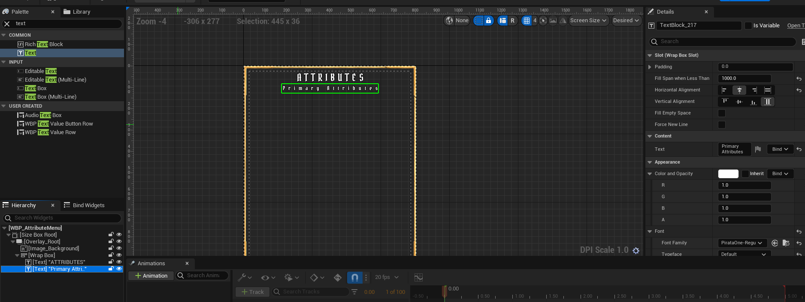

To make some space from the title, add a spacer

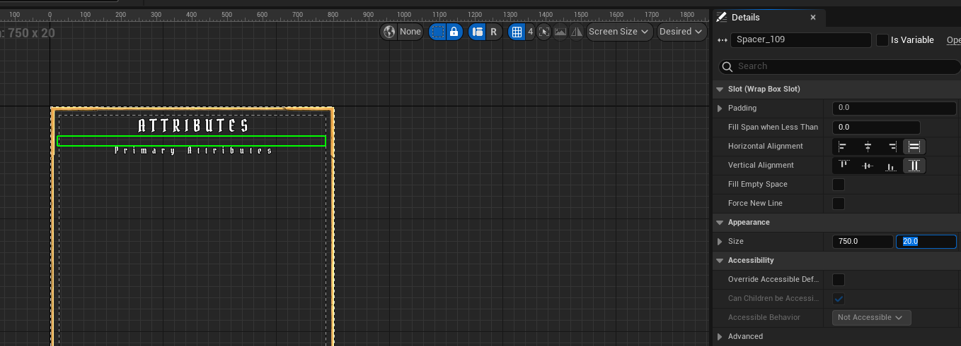

The Y size can be set to make bigger spaces

Ctrl-C/Ctrl-V to copy

Next a Text Value Row (no button) for Attribute points we can spend then the box with button for the primary attributes

In the WBP_TextValueRow, expose the Box Height/Width variables and compile, then add a new TextValueRow to the menu

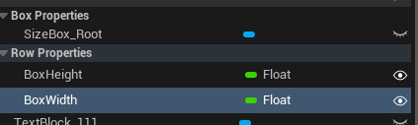 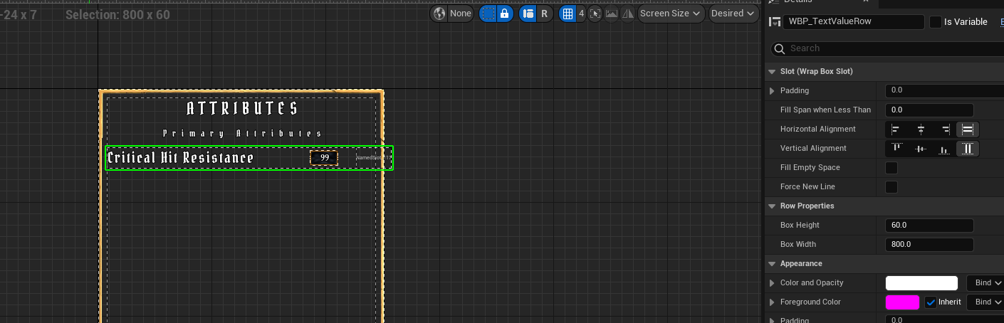

New:

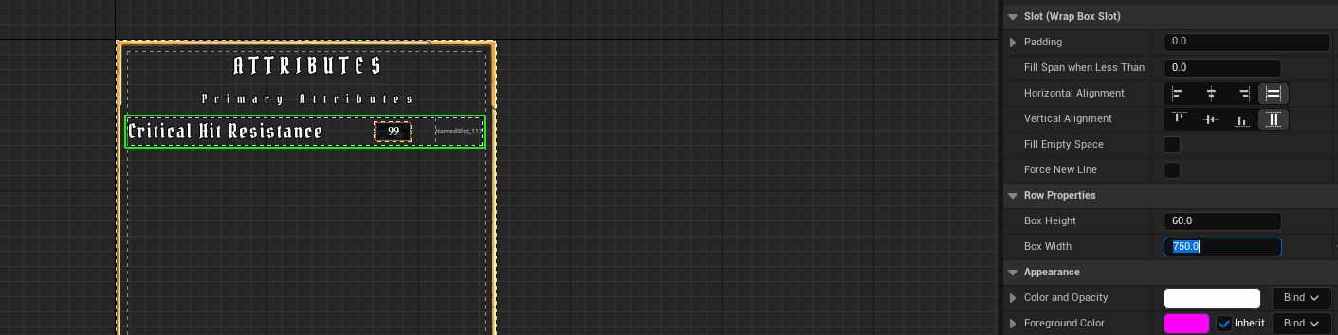

Rearrange a little as the points will not be an attribute, and add button rows

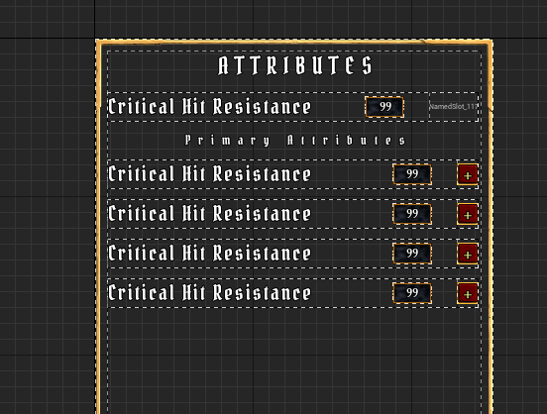

This can be modified to taste, maybe some more padding and smaller row length again?

Pad the wrap box to 40, set width 720

Primary attributes look good

The secondary attributes will go below the primary, and we’ll put them all in their own scroll box

Set a size and fill empty space, add a spacer above

Drag the scrollbox onto the existing size box

Drag a TextValue onto the scrollbox

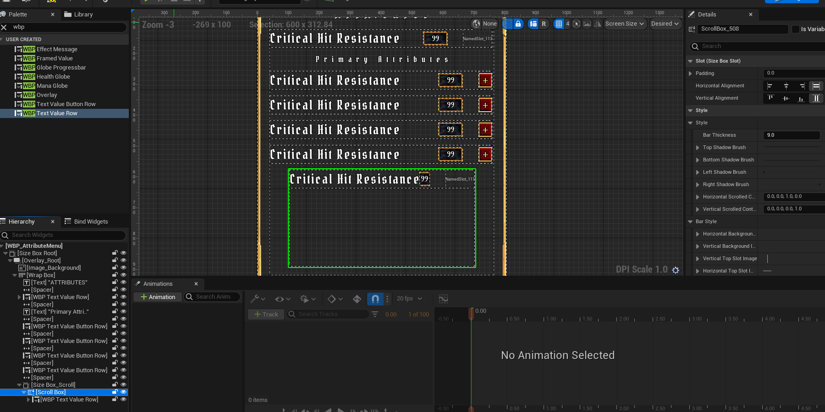

Repeat for all secondary attributes

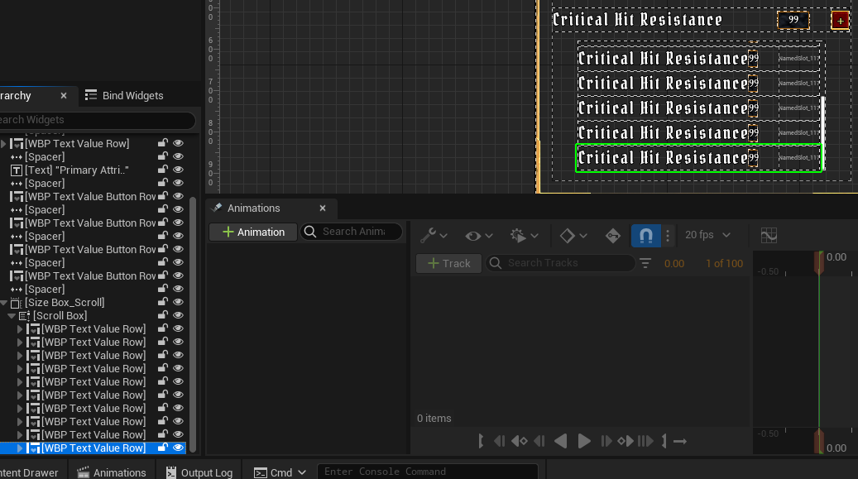

For secondary attributes things look a little cramped and the box slot is taking up a bit too much room, so we can edit properties

Since there are a few of them, maybe have a function to set the font and other properties like space dimensions and named slot later

Finally lets add an image background for the whole menu

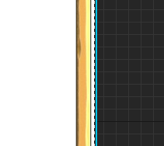

Need some padding

And a background image

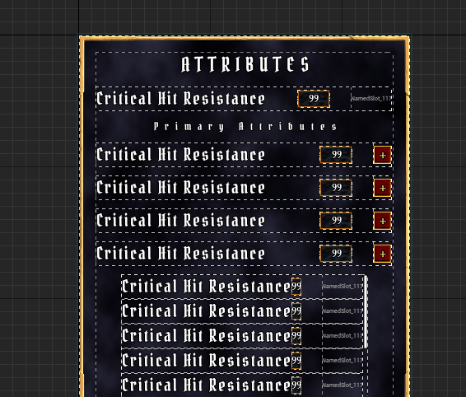

# Button Widget

Add new heading for Secondary attributes (copy the primary text box); adjust spacer size to make things all fit better

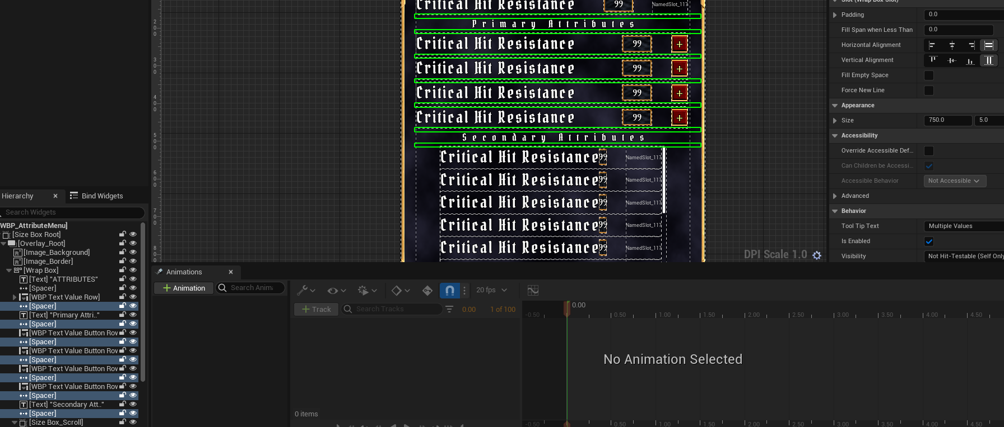

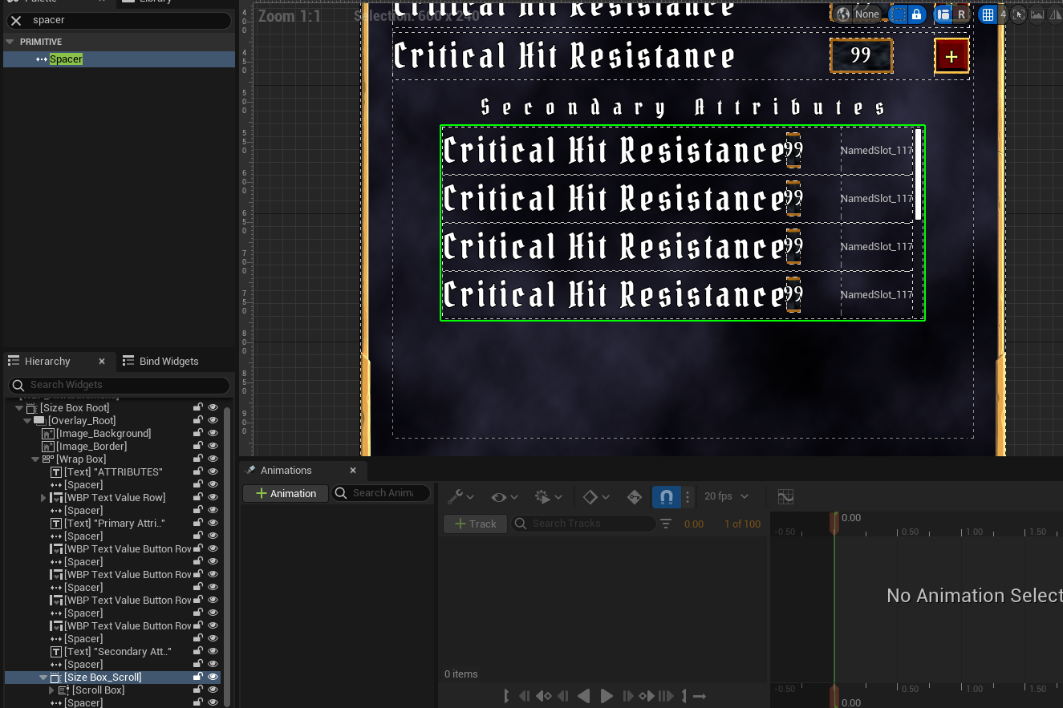

We now also need a X button to close the menu after we have looked at the values

Add a sizebox outside of the wrap box

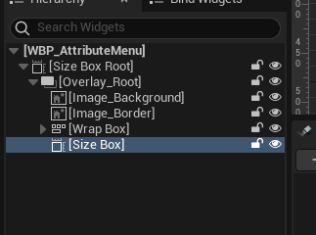

I’ve put this at the top right like in Windows – I feel it’s more intuitive

Set size to 54/54 and padded 25 from right and top

Add an overlay as normal, then a button as before:

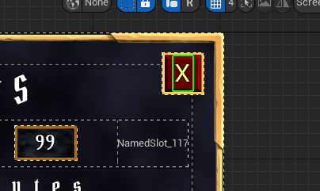

We’re making a lot of very similar buttons; we should probably just BP buttons as widgets themselves, copying the attributes we’ve use for other buttons, like sizebox, overlay, border, text etc

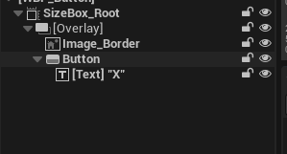

# Wide Button Widget

New button from the main overlay to open the Attribute menu

Based on WBP_Button: WBP_WideButton

# Opening the Attribute Menu

To make Attributes button functional:

Make it a variable in the overlay.

Event Construct: assign to onclicked event for this button to a custom event

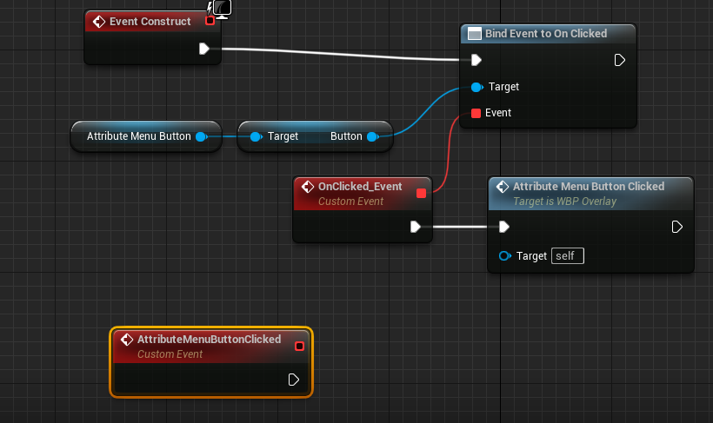

Disable the button on clicked:

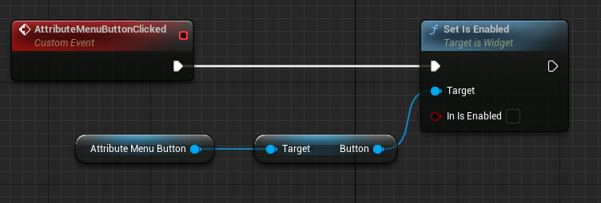

And create widget and add to viewport:

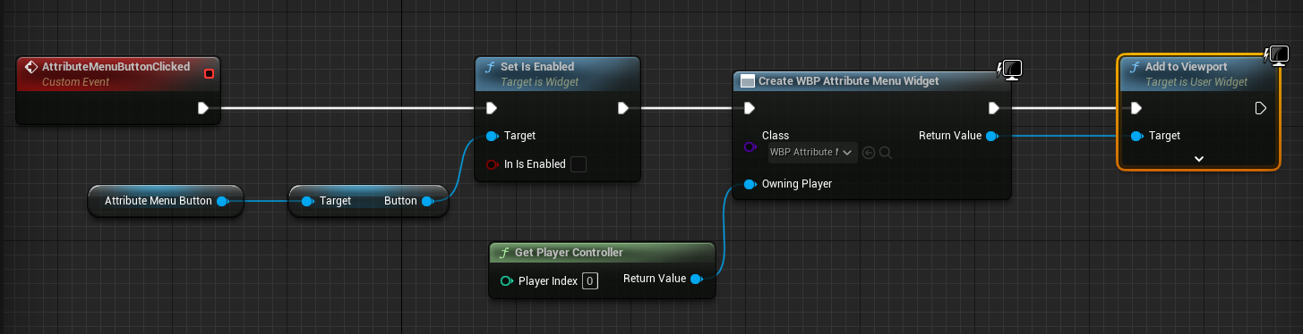

For the moment using 0 player controller but will add multiplayer later

This opens an attribute menu with clickable non-functional buttons but it fills the screen

To reduce the size, wrap the entire thing in an overlay:

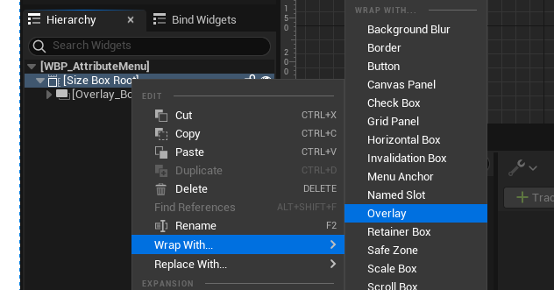

And bam, done!

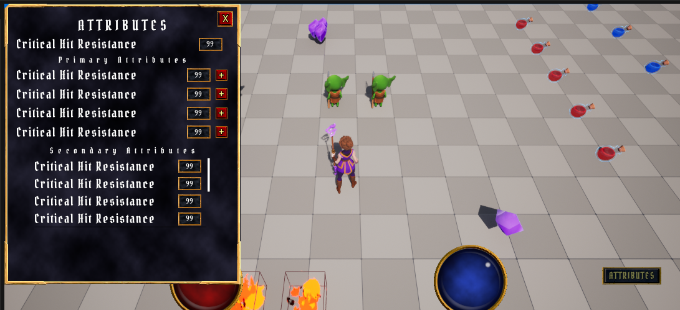

We can add padding and set the size like with Messages:

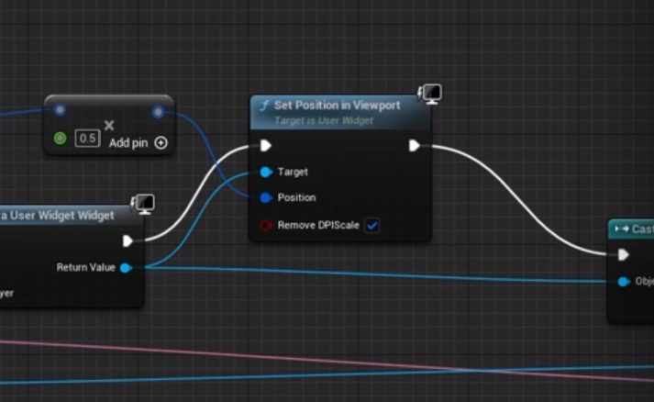

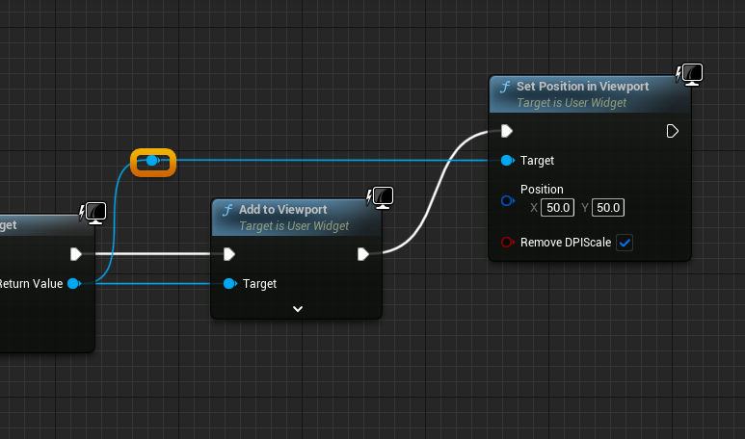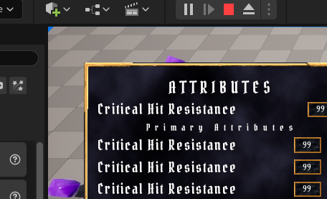

Hardcoded X, Y as 50 but other values, or variables, will work

# Closing the attribute menu

In WBP_AttributeMenu

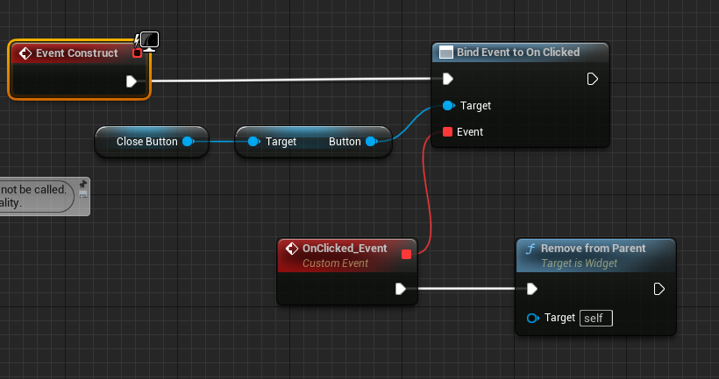

Closes menu but does not turn the Attributes button back on!

Currently the Overlay has a dependency on the Attribute Menu, so we should NOT give the Attribute Menu a dependency on the Overlay!

Send an event dispatcher that the overlay can subscribe to – it’s the BP version of a delegate!

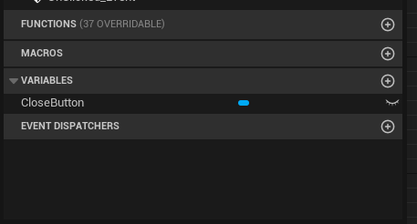

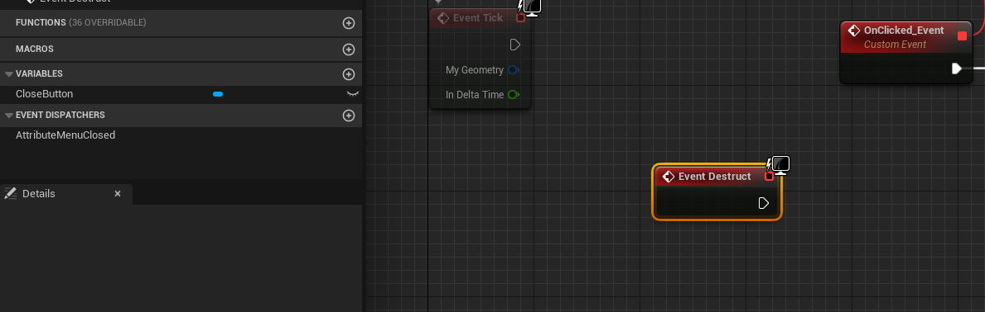

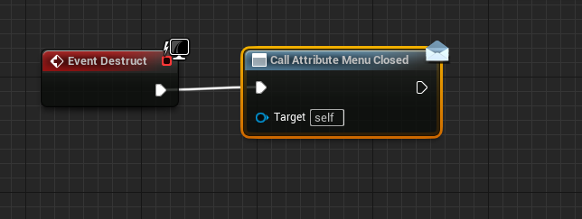

When this is called any other BP subscribed to it will have the event triggered

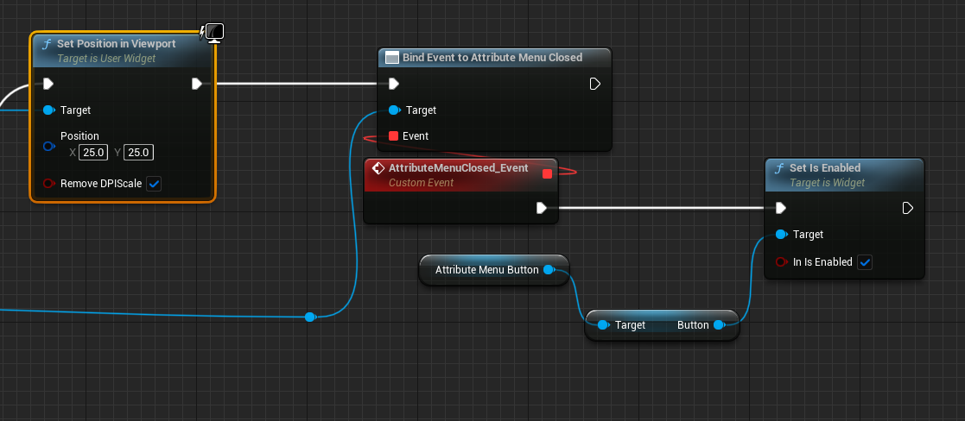

So, there are 2 possibilities here, either the Attribute menu could be created and destroyed each time, or it could be toggled visible/invisible. Both are OK and there’s no significant performance issue from creating/destroying (a tiny one) but this way we avoid a widget living in the background and potentially responding to callbacks while not visible

# Plan for Displaying Attribute Data

Now we have an attribute menu we want to show the values, names and maybe also mouseover tooltips?

Need to get the data to the attribute menu.

Following UI architecture we need a Widget controller, which can subscribe to delegate for attribute changes and broadcast them to the widgets

Do we just sub to delegates for all delegates and make a new delegate for each attribute and broadcast, and continue this every time we add a new attribute?

This will make for a LOT of delegates and broadcasts! Very brute force approach!

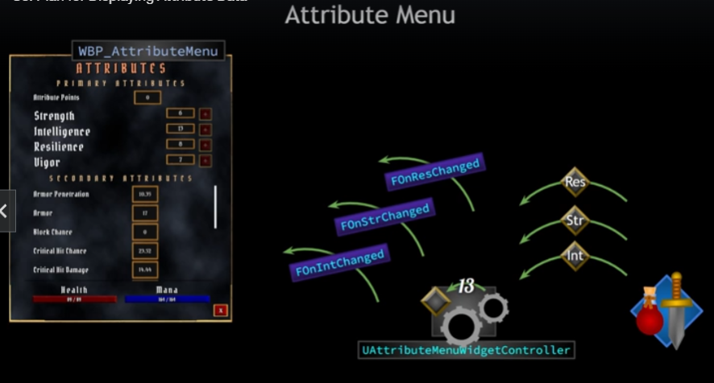

Not very scalable; if we add new attributes we need to bind new callback/lambda in the widgetcontroller to the broadcast and declare a new delegate to broadcast to widgets. 1 new attribute means a lot of code changed in the widget controller and maybe also in BP as well…hard to maintain and expand!

What if Widget controller has code designed to receive broadcasts and then broadcast a generic delegate plus more info, for example each attribute is associated with a gameplay tag, so if str changes, the controller broadcasts one delegate – OnAttributeChanged - plus the str tag and any other information needed (name, value, tooltip description etc. Maybe package into a struct). The widget then checks the tag and does whatever needed. Each row receives the delegate, checks for tags and if a match takes specific data for updates

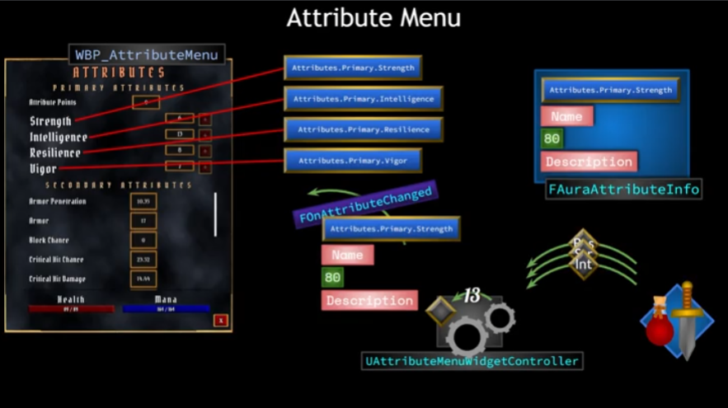

Flow of info: Widget controller binds to delegates broadcast from Ability System

When attribute changes, widget controller knows about it.

Controller takes the attribute, figures out what the tag associated with the attribute is, then performs lookup to find correct struct and send data to widgets.

If Data driven – data table or asset that can package the data

Data assets lookup by more than just name – can use anything we want, for example a gameplay tag

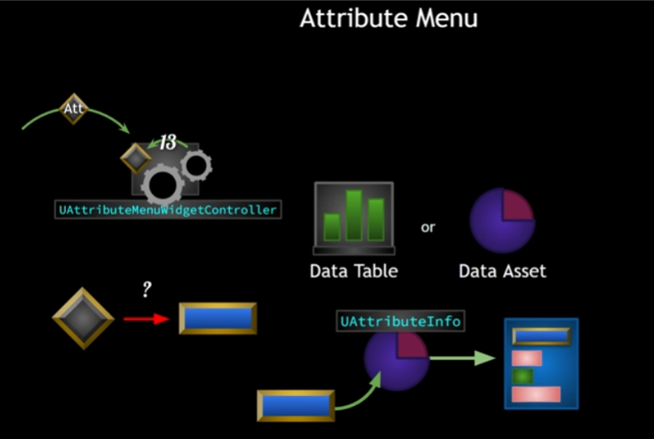

1. Need widget controller for menu set up to get broadcasts from ability system onattributechange
2. Figure out correct gameplay tag associated with attribute- map together
3. Reference tags in C++ - RequestGameplayTag(FName(”Attributes.Primary.Strength”))
   1. Asking Gameplay Tags Manager for a tag struct, giving it name to look up, then if GTM has tag return that tag for us
   2. Error prone, not good to have to type out the string name by hand. Some kind of class that stores global source of tag variables
4. Data Asset capable of receiving gameplay tags and returning aura attribute info struct
   1. As soon as we know the tag for a given attribute data asset can give all the data we need to send up to widgets. Widgets then check their own gameplay tags against the struct and update accordingly.

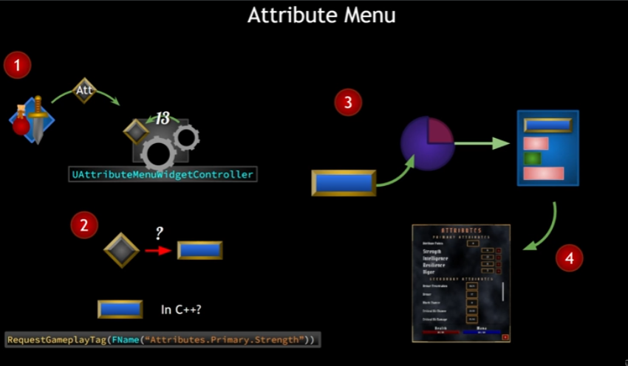

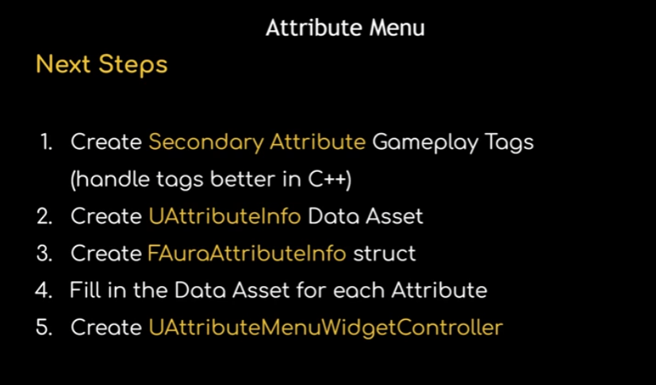

Next steps:

1. Handle tags better, not call requestgameplaytag all the time, centralised source of tags on C++ side
2. Store structs, perform lookups based on gameplay tags to find attribute info needed to broadcast to widgets
3. Contains all info needed to send
4. Fill in Asset
5. Controller ties everything together; listens to ability system broadcasts, performs lookups from data asset, retrieves and broadcasts struct

# Gameplay Tags Singleton

So, we want to add tags for all our attributes. We know we can add them directly from the Project Settings, or from a Source config file and from Data tables using the gameplay tag table row.

However, when we need to use those tags in C++ we have to use RequestGameplayTag (like in Overlay Widget controller)

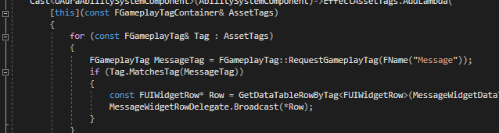

This is a good use case for Requerstgameplaytag, but we don’t want to have to do this every time we need a gameplay tag, we want to use variables and have a central source, so we don’t have to type out strings and worry about typos etc

So create centralised location for the tags we use in C++ domain.

So we’ll create a C++ class to store them – a unique struct enforced by using Singleton pattern

New C++ class in the project root, parent class: None

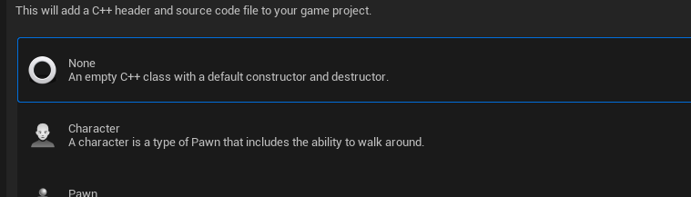

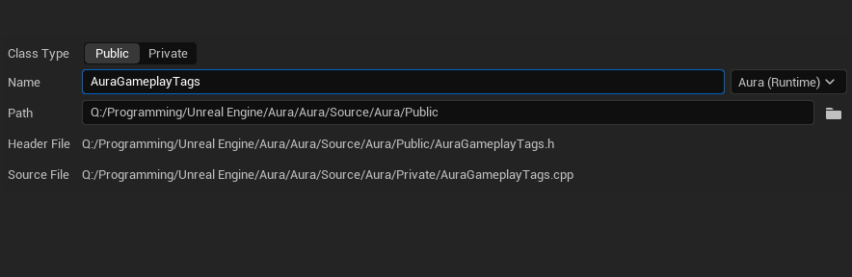

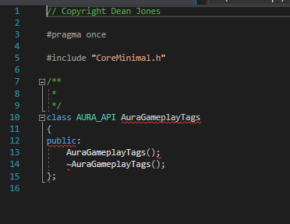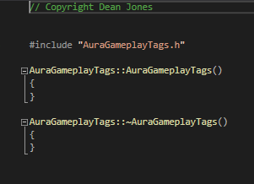

Completely empty!

But not minimalist enough!

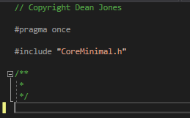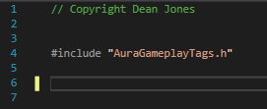

Stripping out the class declaration and constructor/destructor to make it a struct:

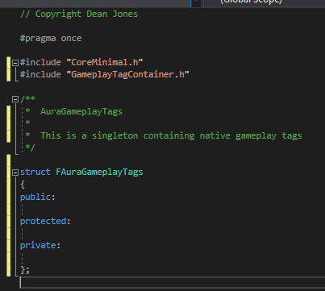

Structs will default to public permissions, but I’m *explicitly* creating public, protected and private sections here

‘Native’ in the sense that the tags are created within C++ and available there (but will be available in editor and BPs also

Note the inclusion of GameplayTagContainer – we will be using the GameplayTag type

Because this is a singleton we’ll design this in a specific way

* Create a static Getter function
* No need of an instance of the class to exist to call one of it’s static functions

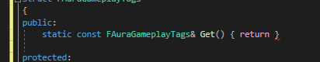

static const FAuraGameplayTags& Get() { return }

Static function

const because not making changes ofc

Uses the type of a reference to the one and only instance of FAuraGameplayTags in the project (this)

Function is Get() and it returns the only instance that exists

Instance will be a static variable on this class – the class itself will have a variable to store the only instance of itself

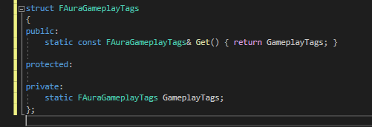

So, once this is constructed we can call the static function Get to get the only instance of this struct

So a static variable like GameplayTags we need to go into the CPP and explicitly declare the type here:

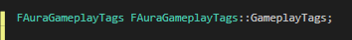

Next we will need a public function to initialise the tags – to create the native gameplay tags

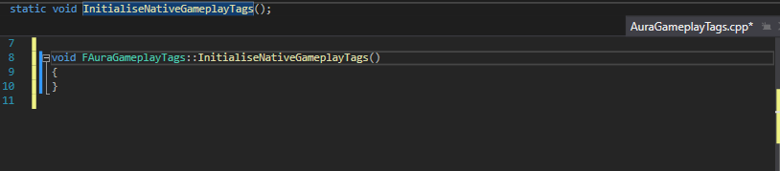

How to start initialising:

Get the Gameplay Tags Manager – when we create a tag, it’s registered with the tag manager, a unique object within the project

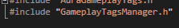

Note: GameplayTagsManager.h – Tags with a S!

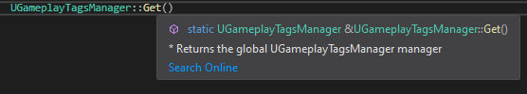

Look at this! A static function called Get() that returns the one, and only, GameplayTagsManager. That’s the same pattern we’re using here

So we get that and can use functions on it like:

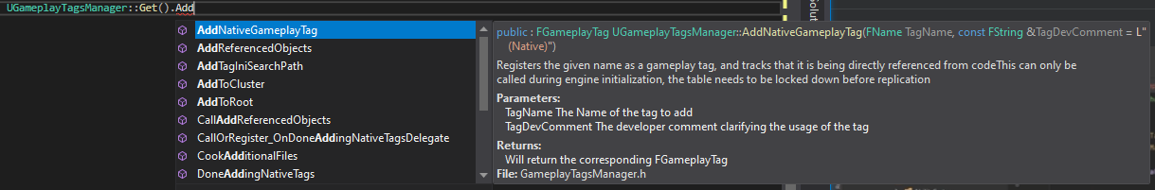

This requires the tag name and has a tag dev comment – specify name and an optional comment

We’ll define a native gameplay tag, starting with secondary attributes:



Attribute name, Dev comment.

Now we have a Singleton that we can always get with the Get function and we have created the static gameplaytags instance here, which is a global singleton

At what point should we call this function to initialise the tags?

Probably as soon as we can, to initialise them before anything tries to use them, using a custom asset manager.

# Aura Asset Manager

Asset manager is another singleton, set at the project level, responsible for loading primary assets and is where we’ll initalise AuraGameplayTags.

The class:

We will now, like AuraGameplayTags, create the new class in the public root for the project, based on the AssetManager parent class

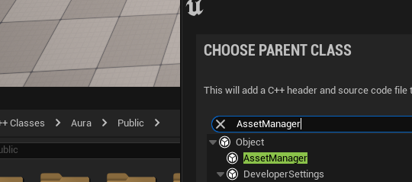

As with the other singleton we’ll have a static Getter

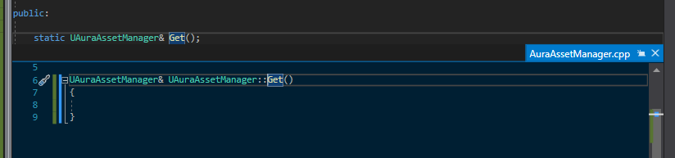

What does the Get() return? The Engine’s asset manager (but we’re going to cast it to the UAuraAssetManager type)

We’re going to set the asset manager in one of the config files

Once the project has this class set to be it’s asset manager then we can define the static get function to return hat asset manager cast to this class.

We get the asset manager from GEngine

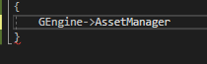

But first we will assert that GEngine is valid – it should be; if it’s not we’ll crash intentionally because we have bigger problems!

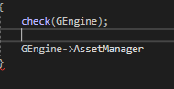

So we have the AssetManager and we’re casting it to our custom asset manager:

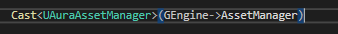

This will return a pointer

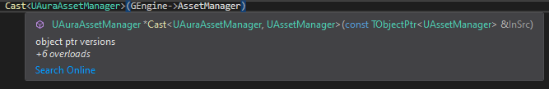

So we can have a pointer to UAuraAssetManager called AuraAssetManager



But the Get function does not return a pointer, it returns a reference

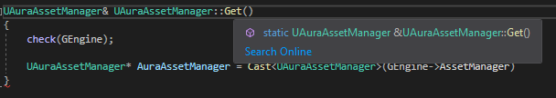 so we’ll have return the dereferenced pointer

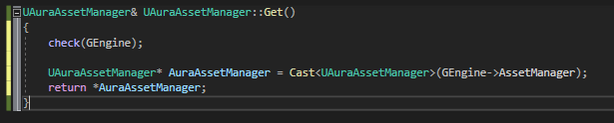

An alternative would also be:

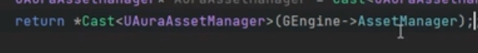

I’ll keep the pointer for now in case I need it later, can always refactor it

So, that’s the first thing down, defined the Get function that returns the type we wanted

Next our custom asset manager needs to override a function that exists on the AssetManager class.

It’s a protected function called StartInitialLoading

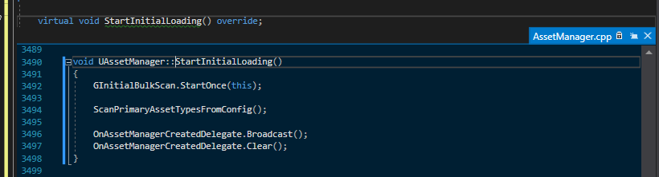

This function is called very early on and this is when we start the initial loading for the assets for the game.

Perfect place to call the InitialiseNativeTags – it’s a static function so we can call it here!

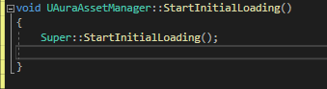

We’re going to init AuraGameplayTags, so we’ll include its header and:

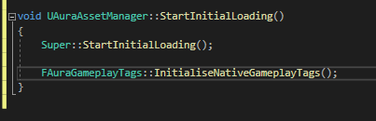

This will Get the Gameplay Tags Manager, call AddNativeGameplayTag, then create the Attributes.Secondary.Armor gameplay tag

Last thing to do it set this AuraAssetManager to be the project’s Asset Manager in config files

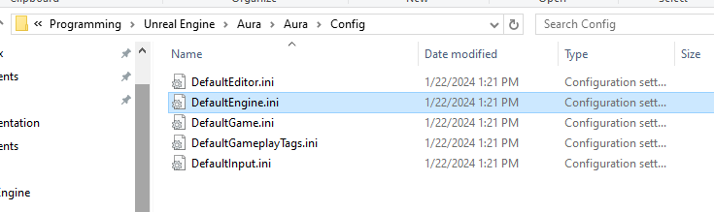

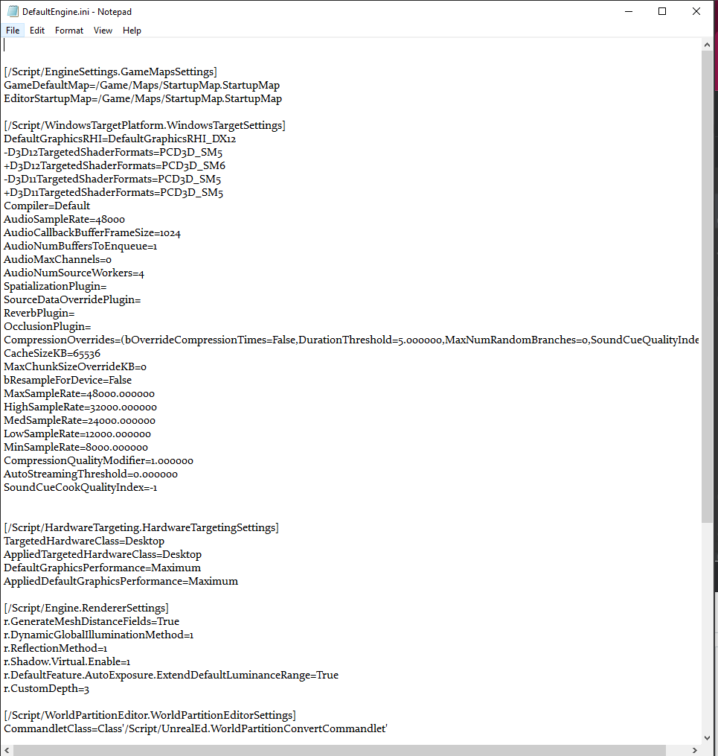 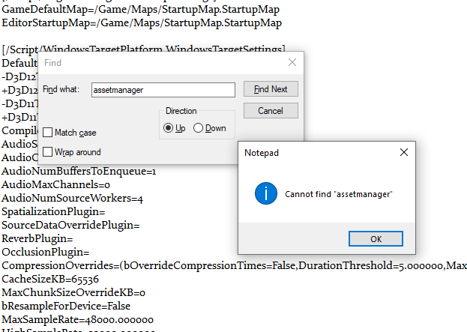

Good idea to search before making changes, to be sure we didn’t have it set already!

We need the section /Script/Engine.Engine

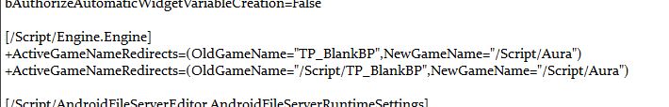

And we add this line at the end of the section:



The generic would be:

AssetManagerClassName=/Script/<projectname>.<assetmanagername>

Save, compile and launch!

Now when we look at the project settings in UE:

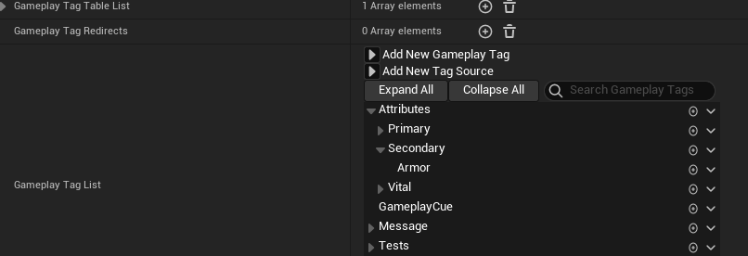

The Secondary attributes category and Armor is now present :D

But more significantly if we mouseover:

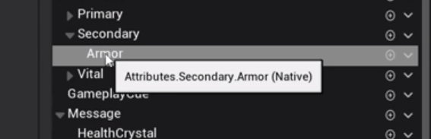

It’s a Native tag. Other tags are not:

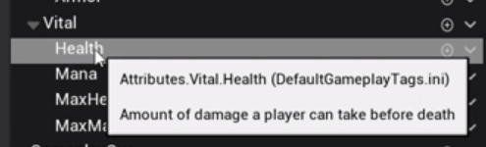

This tag is defined in the ini and can be used for BPs, but not in code.

What about other tags, like this one, defined in the data table?

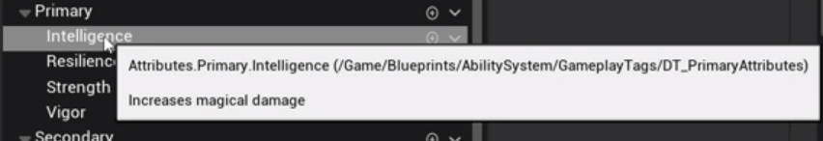

What if we want to make those native?

Well, they can just be trashed, but be careful, because if they’re used in assets and BPs, they’ll need to be set again. But otoh, we know how to do that now and we’re all set up to initialise them with our asset manager

Last piece of the puzzle is how do we use these tags in our code?

Let’s test accessing in code:

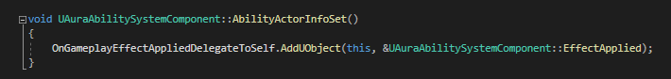

Goal: access the native gameplay tag armor and prove we have accessed it

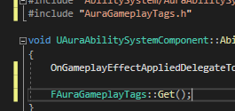

First we call the Get()

We’ll store the struct in a const reference (we don’t want to copy it!)

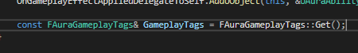

And now we have the singleton we can access the tags:

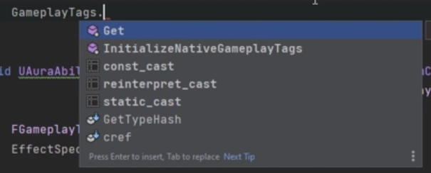

Hmm wait, we don’t have a variable on that singleton to put our armor into!

Adding one in the header:

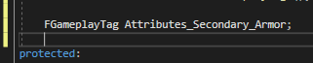

We need to set this variable, and we know we’re *creating* the gameplay tag, so we need to associate this 

With this





Hmm, no because

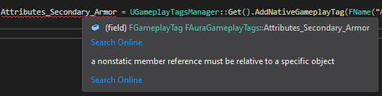

It’s a static function, so we need to have some object of this type (there’s only ONE object of this type) and we need to set the gameplay tag on that object

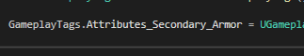

Done! We have access to the one and only instance of it here

Which means that in the ASC we can access Armor

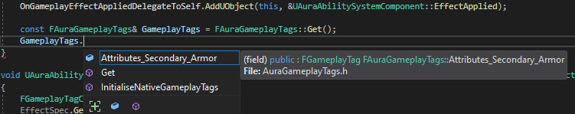

And because it’s a gameplay tag and they can be converted to strings:

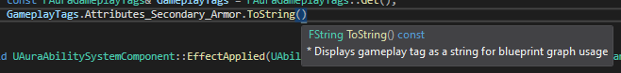



(watch out for all the parentheses!)

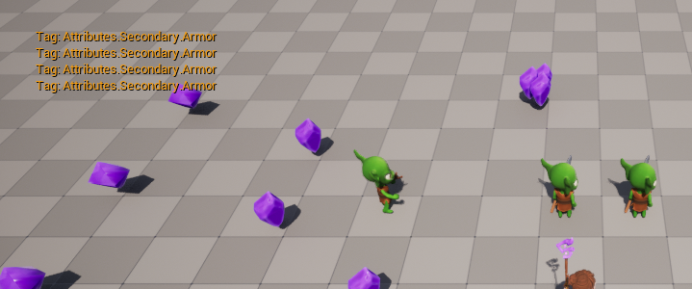

Wait, why is it printed 4 times?  
Because it’s printed from within the ASC…Aura plus 3 Goblins means 4 instances of the ASC::AbilityActorInfoSet() printing to the screen! If we delete a goblin:

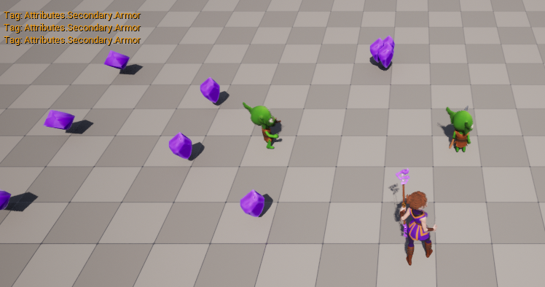

3 prints - There’s still only one Tags struct existing

Now that we can add native gameplay tags, we should add all the attribute tags here in code

# Native Gameplay Tags

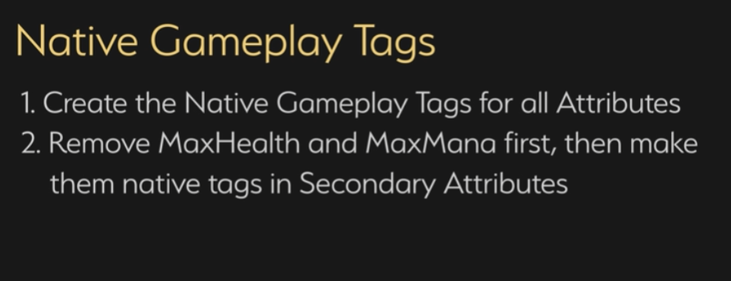

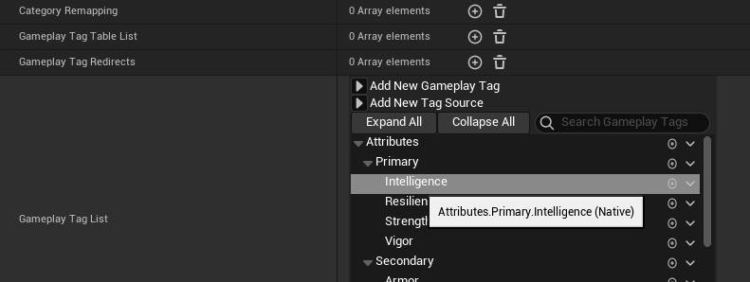

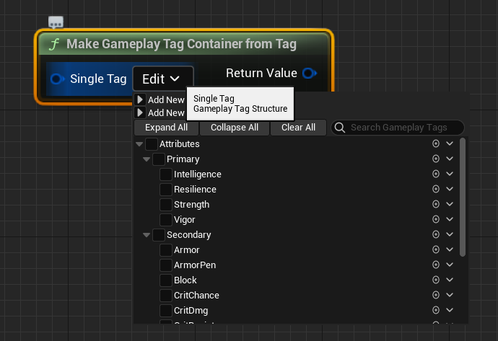

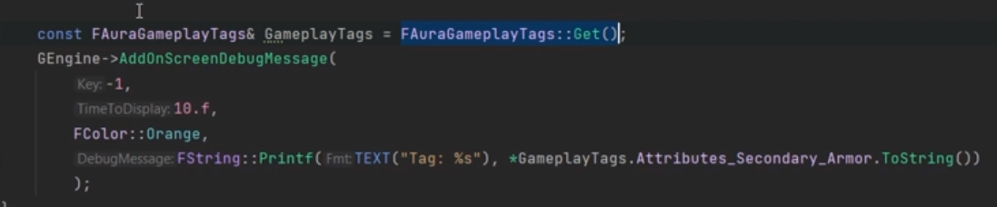

Also works:

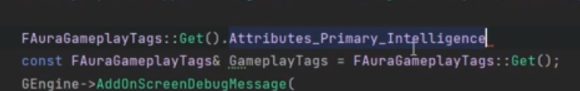

# Attribute Info Data Asset



Secondary Attribute Gameplay Tags are done and (most) Attribute Tags are now C++ Native

Now we need (2) a Data Asset – an asset to store info in the form of a struct: (3) the FAuraAttributeInfo struct

New C++ class (it’s related to the ability system so using that folder is fine)

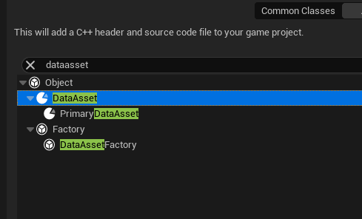

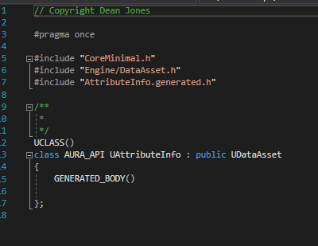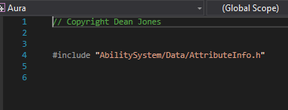

Data assets allow the opportunity to store asset information in a BP settable class

We’ll be creating a struct here to store all the information associated with a given attribute; once an attribute changes we can broadcast this struct object up to the widget blueprints who will receive it an update themselves with that info

We’re making a new struct for Attribute info so:

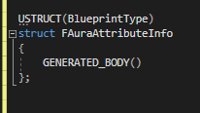

The struct will need a GameplayTag to identify which attribute this info is for

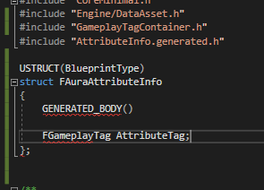

If we’re using Gameplay tags we’ll need to include the GameplayTagContainer’s header

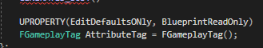

We’ll give it a default value and UPROPERTY so we can use it in BPs.

So, that’s how we’ll identify each of these struct objects, by Gameplay Tag

The Info we need to pass up to widget will require:

Some Text for the attribute name, so we can set the name in the attribute menu using FText (always use FText for user-facing text:

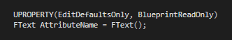

And also the description of the attribute:



And a value. We want this to be readable by the BP, but we don’t want to be able to edit the value from within the data asset, only read it, so we’re going to expose it as BPReadOnly only

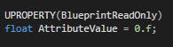

It’s still scoped public in the struct so we can set the value in C++

We now have the struct:

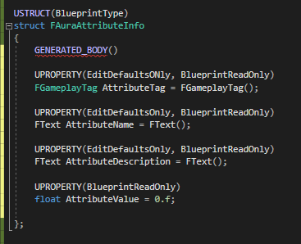

We can always add more fields later if we want!

Now we want the data asset to have something filled with structs. An array comes to mind!

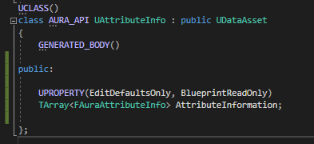

This array is basically a list of actor info, with each attribute being it’s own struct and the array as a whole being the collected actor info.

So we now have an array of these structs. Next we need a function that will take a tag and return the correct attribute info from this array based on Gameplay Tag

So, the array is of type FAuraAttributeInfo, we will pass in a gameplay tag for the attribute (and not change it so const) and also a bool for if there’s nothing found:



Not found is False by default, so if we pass in True then if we try to find an attribute info struct from this array, we’ll use a Log to log an error:

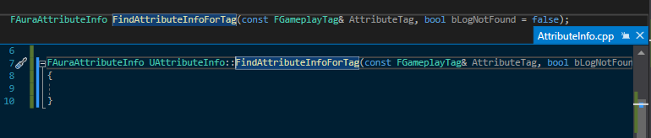

So, we’re taking in an Attribute Tag, which means we need to find the attribute in our array that has that tag

Let’s use a for loop!

For each (reference) FAuraAttributeInfo (the struct) in AttributeInformation (the array)

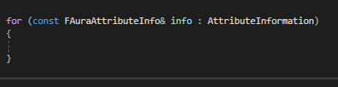

If the struct’s AttributeTag value is the same as the AttributeTag we pass in

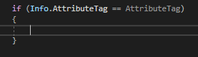

Instead of the == we could also use the MatchesTagExact()

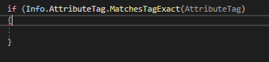

If it matches, we’re good and we can return the Info

If not:



And then we need to return an empty FAuraAttributeInfo

The function as a whole:

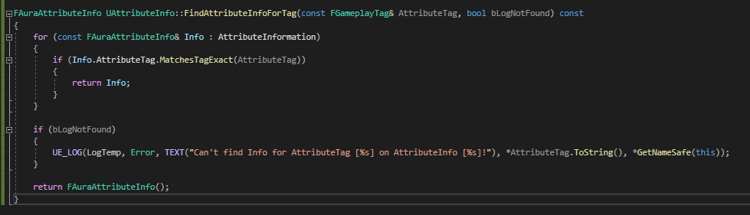

Now we have the data asset set up we can blueprint it and fill it!

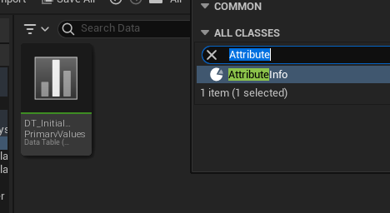

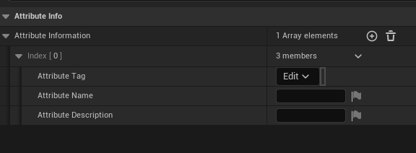

A new line contained by default the fields we specified should be exposed in code – the ‘AttributeValue’ float is a part of the struct, but is not exposed here!

We can add elements to the array here for the attributes

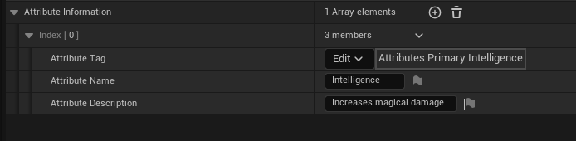

# Attribute Menu Widget Controller

New class based on the AuraWidget Controller

For the moment just overriding 2 functions:

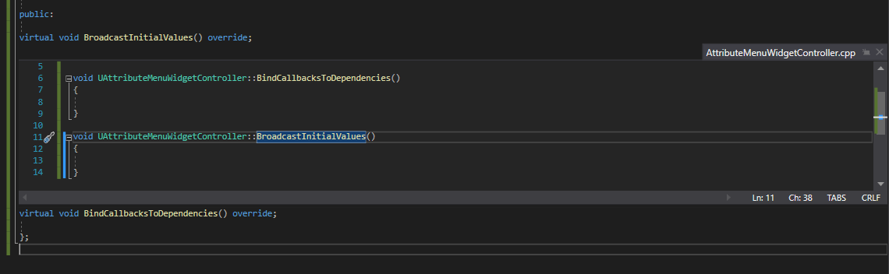

The signature is similar to OverlayWidgetController

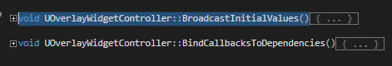

And because the parent version which is being overridden has no content there is no need to call Super

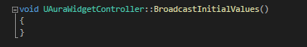

(if we later add to the parent and want it called here too, we can come back and add later)

This will be used by the attribute menu, so the attribute menu needs it’s controller set, or needs a way to set it’s own controller

We need a place that this widget controller should be constructed

Looking at the sibling controller, OverlayWidgetController, it’s contructed in the AuraHUD.cpp with GetOverlayWidgetController

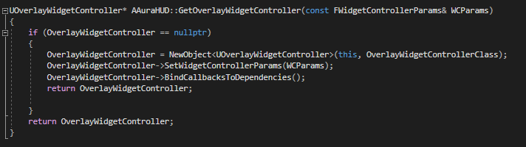

This requires WidgetControllerParams

Widget Controllers have the 4 key variables, which can be packaged into WidgetParams





Since the AuraHud itself already has this struct built and has an Overlay Widget Controller variable, this is probably a good place to construct the Attribute Menu controller as well

The variable is private, so we have to go through the Getter function to get it, and if the getter sees that the object has not yet been constructed yet, it will construct it and return it. So this is the pattern we’ll follow for the new Attribute menu widget controller. We’ll set this up, and also create a way to easily get the Widget controller without having to go through a number of classes to find it; if we want a widget to set it’s own controller it’s better it not have to find the HUD class, and then ask the Hud class for a widget controller. An easy to use BP Function to access the controller is far better

**This is a perfect use case for creating a Blueprint function Library!**

If we create a BFL we can create some blueprint callable static functions and use them to access things in an easy manner in blueprint

# Aura Ability System Blueprint Library

We want a way to access the widget controllers for the project, which should exist for only a single instance like the Overlay and Attribute Menu widget controllers

Looking at the attribute menu the goal is to be able to access the Event Graph

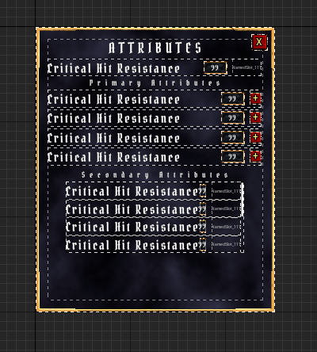

In the event graph, we want to be able to simply type something like

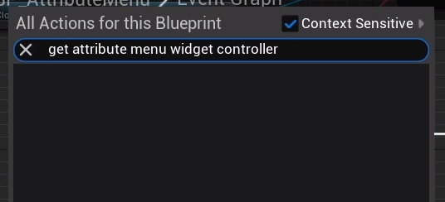

And have a function available that returns the attribute menu widget controller

And then, as soon as the attribute menu is constructed (eg in event construct ) we want it to set it’s own widget controller – we don’t want it done in the overlay class

WBP_Overlay **could** set the widget controller for the attribute menu as soon as we click the attribute menu button, because this is where we’re constructing the attribute menu widget

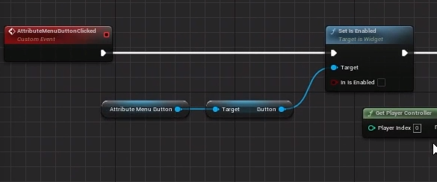

We can’t do that with some of the other overlay widgets, like health and mana globes, because timing is important here, and the widget controller for the overlay is set at a specific time, and the Health and mana globes share that widget controller. And we do want to time those things correctly – we want to set the Overlay widget controller before the health and mana globe controllers are set. So in that case, the overlay can set those controllers

But for the attribute menu we are creating a new widget every time we click the button, so we want it to be able to set it’s own widget controller, especially since it’s a different controller from the one the Overlay uses – the Attribute Menu Widget controller instead of the Overlay Widget Controller

Hence the need for a BP library, like the one that the Ability System Component has

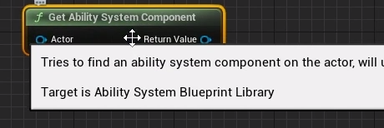

The BP Library is a collection of (usually) static functions that are declared in a class (like the ASC BP Library class) and exposed to BP in the from of these BP nodes (BP Pure)

New class:

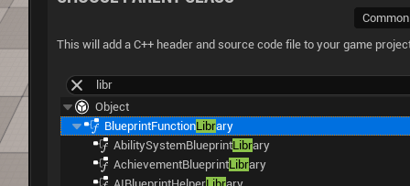

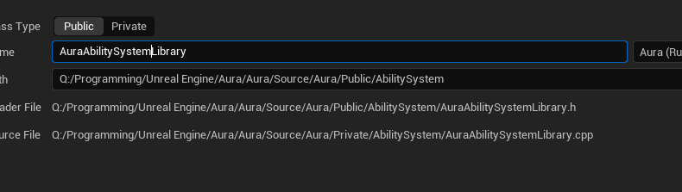

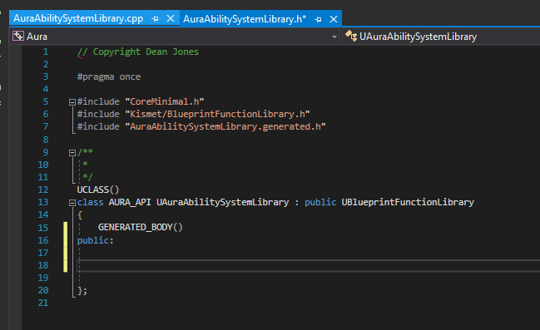

The first function to add is the one we want for the controller, a Getter for the Overlay Widget controller that already exists, so we can confirm that this new function library will work correctly in Blueprint

With BP Function libraries we makes these functions static, because we don’t plan on instantiating this class, we’re just planning to call it’s functions

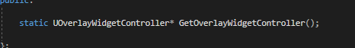

First static class. Since we are returning the UOverlayWidgetController type, we need either to include the parent or to forward declare; on this occasion we’ll fwd declare

Argument: This is a static function. If we are to trace our way up to the HUD, we need to do so using an object that exists. But a static function cannot access any objects that exist in the world, because the class itself, to which the static function belongs, might not exist in the world! The static function can be called directly. This is why many function libraries in the Engine require a World context Object - it needs a reference that it can use to trace its way up somehow to something we want to affect

So the GetOverlayWidgetController class needs some object we can use to have context for the world that we’re in.

This will be a const UObject pointer called WorldContextObject



The function is set as a BP pure, so no execution pin

Definition:

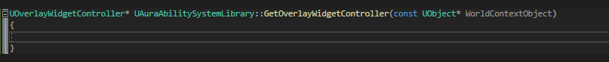

We need to get the OverlayWidgetController somehow, and return it to the caller

To do this we’ll need the player controller. But we’re planning on calling this from a widget – there’s no other reason to call it, widgets are the only thing that need widget controllers

If we’re calling from a widget we are calling it from the perspective of a local player. A widget will ONLY exist for the local player, so we want the player controller associated with that game instance, that specific session.

So, we’ll first call UGameplayStatics::GetPlayerController()

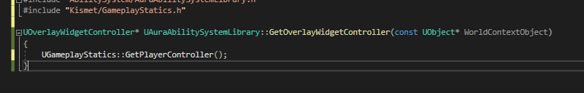

(remember the include)

The function requires a world context object



We have one, so we’ll pass it in along with the required index

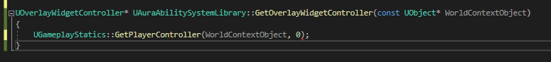

Now we have a player controller, and can store it 

We should check that this is not a nullptr:

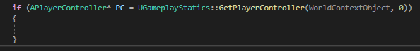

And since we can always access the HUD from the player controller, we can repeat this if check variable declaration trick again:

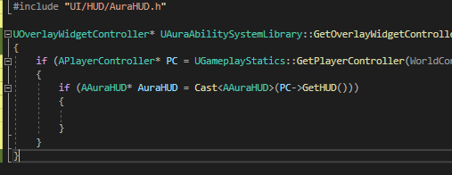

Now we have access to the AuraHUD, but we’re only inside this IF if we succeed (and we should)

Now we have the HUD we want to call GetOverlayWidgetController on the HUD

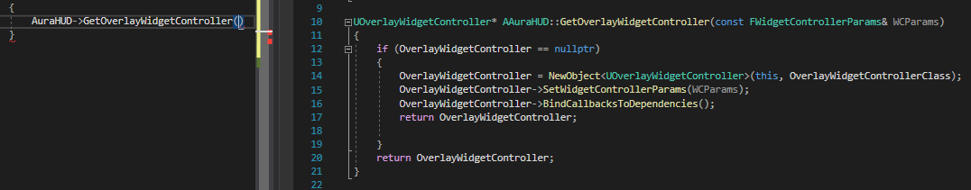

BUT: This requires we pass in a FWidgetControllerParams struct filled in with the 4 key variables!

We already have the Player Controller; we next need the PlayerState – we can get that from the player controller

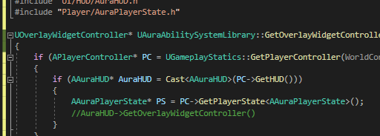

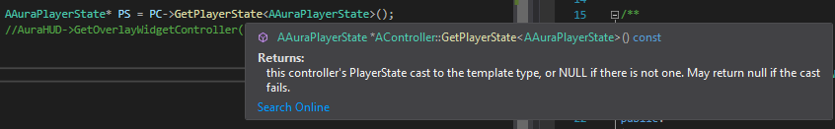

This function returns type AAuraPlayerState because the Getter can take an input template parameter, so we can specify the Aura custom type

Now we have the player state! As a reminder we need PC, PS, ASC and AS

Since we now have the AuraPlayerState, we can cast to it, because this already has access to the ASC and the AS and has functions for both:  
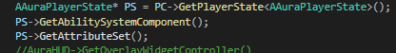

…and store!

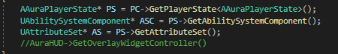

Now we have the 4 key variables we can make that params struct to pass in

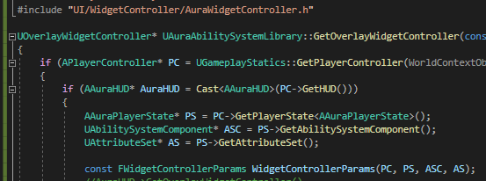

Reminder: the type FWidgetControllerParams is defined in AuraWidgetController.h, so we need to include that now

We now have the widget controller params set, so all we need to do is to get AuraHUD and call OverlayWidgetController!



The function needs to return that OverlayWidgetController so:

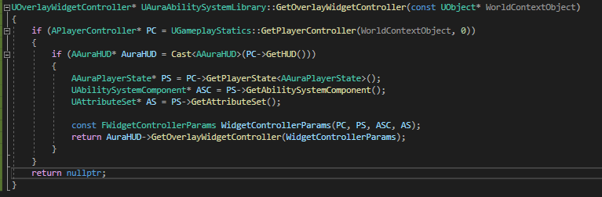

And now when we look in the Editor:

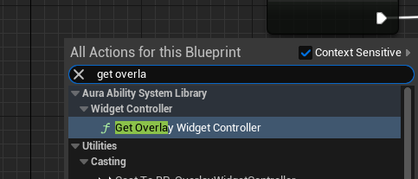

We can choose the world context object, including ‘self’ for BPs, and return an overlay widget controller object reference

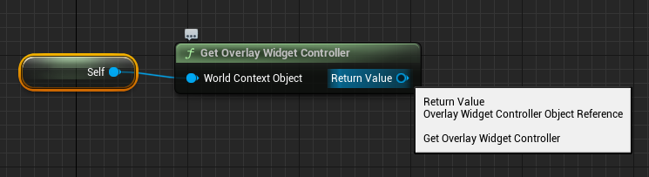

Now this is verified to work for the Overlay widget controller, we can go ahead and do the same for the attribute menu controller!

# Constructing the Attribute Menu Widget Controller

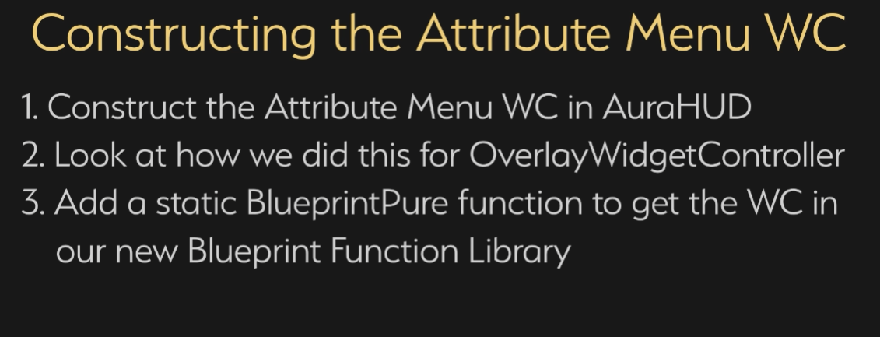

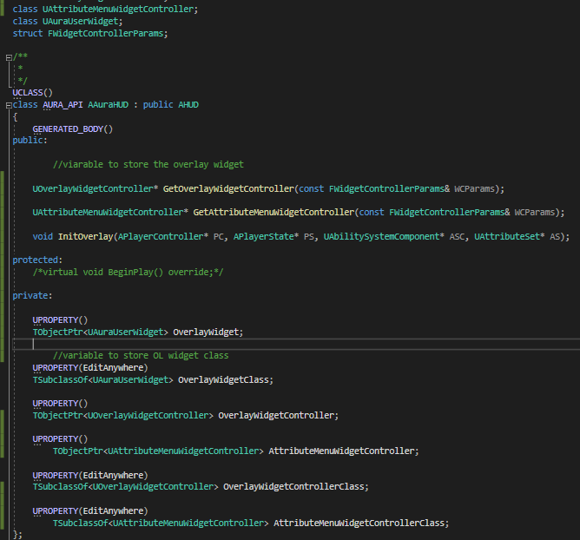

HUD header:

Create the controller variable for the menu, and a class variable for it.

Create a getter for the controller taking in the params struct

Forward declare the class for the controller

Cpp:

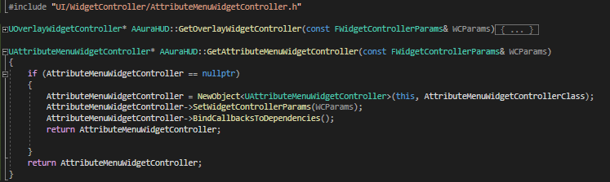

Include header

Build getter

Check for the controller and return

If null Newobj based on the controller classm set params bind callbacks and return

In lib fwd declare the controller and make a new getter:

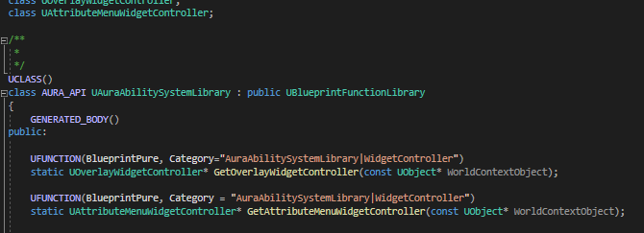

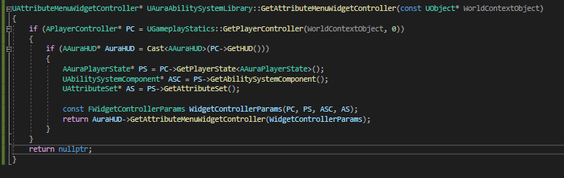

The only difference here is that this returns a different object type:



This is now functional and the Attribute Menu BP can call this getter and set it’s own controller:

First, we want a BP for the controller, but it needs to be made Blueprintable in code: 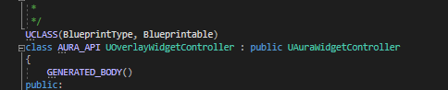

in editor go to the HUD class and set the attributemenucontroller class

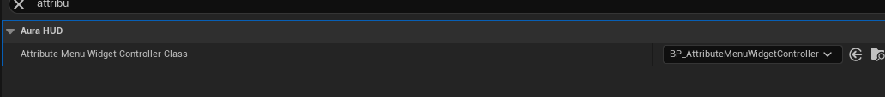

We can now use the BP’d controller in the construct for the menu

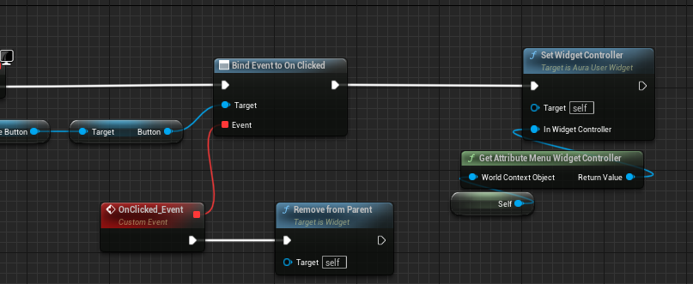

Finally, we want to verify that the controller is set correctly.

When a user widget has it’s controller set, the setter controls the BP implementable event controller set

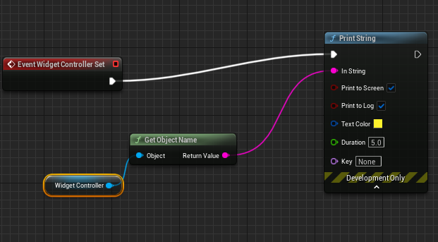

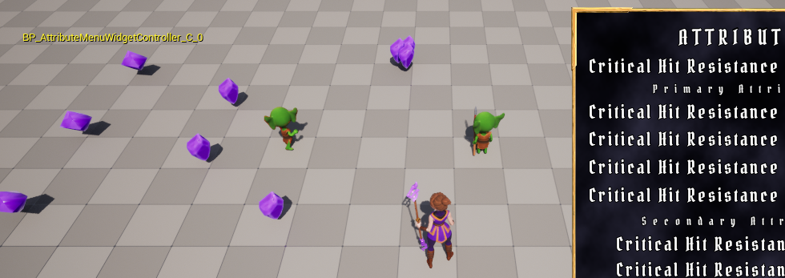

# Attribute Info Delegate

We now want to bind callbacks to dependencies and broadcast initial values!

We want to let the widget know what it is supposed to display, which is why we made the Aura Asset Info struct

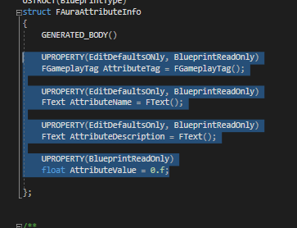

When we broadcast info to the menu we are broadcasting the highlighted items

The menu or associated widgets will receive the broadcast, check it’s own data by Gameplaytag, against the data here

First:

Get AttributeSet in the widget controller and find out it’s value

We already inherit the AttributeSet variable:  


It’s a UAttributeSet so we need to cast it

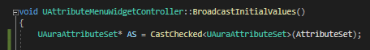

Now we have the AttributeSet

Now to get the value of an attribute. We’ll start by just getting Strength, see what the value is and broadcast info up to the menu widget

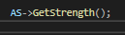

Delegate:

To broadcast we need a delegate that can send the struct; multiple widgets will want to bind to this so we’ll declare a dynamic multicast delegate with one parameter (the struct)

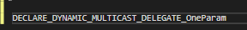



We have the signature here, we’re broadcasting an object of AuraAttributeInfo type and also forward declaring it

Now we can make a variable:

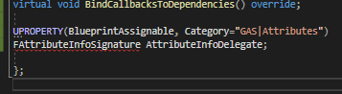

Currently we’re only broadcasting the value of strength but we want to have any of the widgets bind to it too

Because we are broadcasting an AuraAttributeInfo we need to fill it in with info.

We have a data asset that already has a name, description and value field! So the Widget controller needs the attribute info data asset

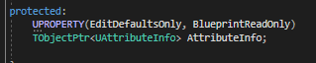



The return is:



So we can keep this as a variable@:



And note that it is not a const, because we want to set it so:



Everything else was set – we set it in the BP for the data asset, but we didn’t expose the attribute value to the data asset because we want it to be the CORRECT value at the time of broadcast

Now we have correct attribute info we can broadcast it using our AttributeInfoDelegate!

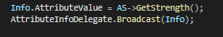

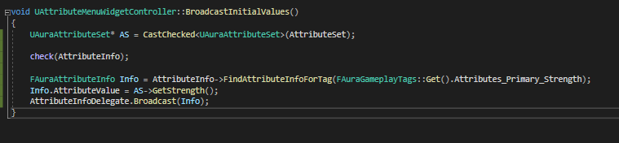

So in BroadcastInitialValues we are broadcasting the Info. But the widgets need to bind to the delegate *before* we broadcast the initial values

So there are a couple of things we need to do. We need to in blueprint

First we need the AttributeInfo set on AttributeMenuWidgetController

Then we need to make sure we bind to the delegate in order to receive the info on the BP side

After launch, BP_AttributeMenuWidgetController has a new exposed property!

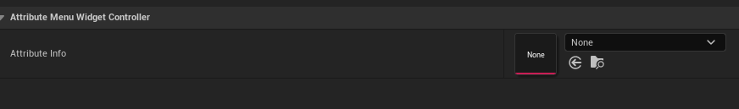

And it is compatible with the data asset!



So, now we can bind to the delegate and decide when to call Broadcast Initial Values

Let’s go to the Attribute Menu widget and look at what we need to receive

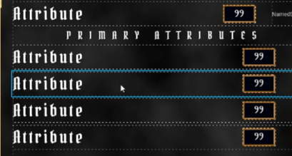

Each row needs to receive data, either when the attribute changes or when we broadcast initial values

We want to assign an attribute to each row, so each row should have it’s own gameplay tag – an attribute tag

To do:

Add an attribute tag to each row in the menu widget

For now though, let’s subscribe to the delegate from the widgets so we can see *something*

Go to the TextValueButtonRow class and set a controller in event construct

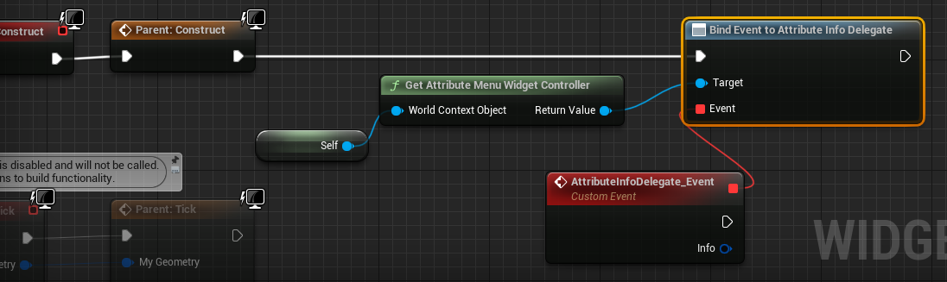

Each row should have it’s own tag that it checks, but for the moment will just break the info and set things on the row

Currently there’s no access to the text or number in this class, but we can go to the parent and expose an inherited function

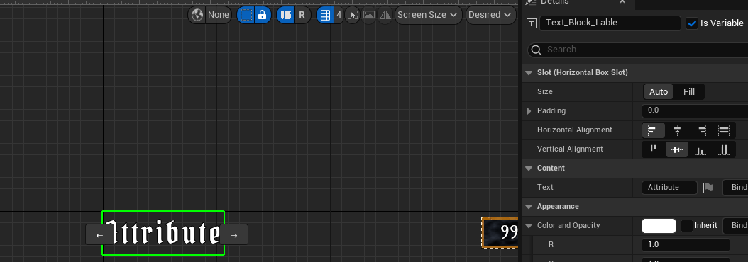

Set the text block to variable, go to graph

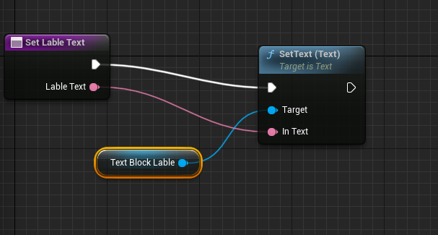

Text Value Row now has a function to set text, so TextButtonRow will inherit

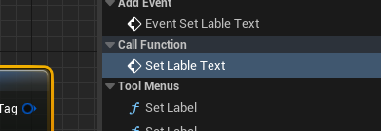

This will now be set for the attribute menu when the delegate is broadcast from the widget controller

Now to see an update in the menu, we need to broadcast that initial value. But when?

Obviously after the controller is set!

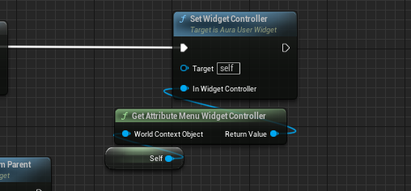

But broadcast initial values is not an exposed function.

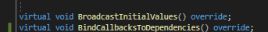

We know that BroadcastInitialValues is a virtual override, so we go to the base class AuraWidgetController.h

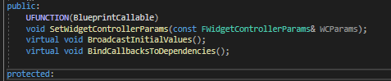

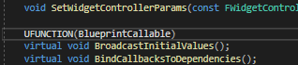

Compile, run and in the WBP_AttributeMenu:

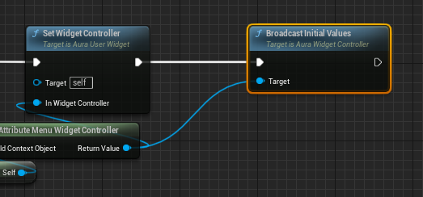

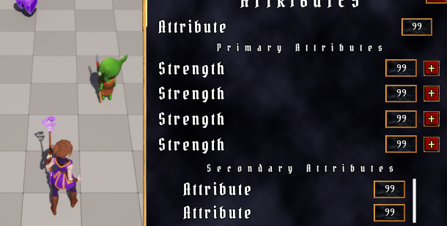

Next the numbers:

In BP_TextValueRow:

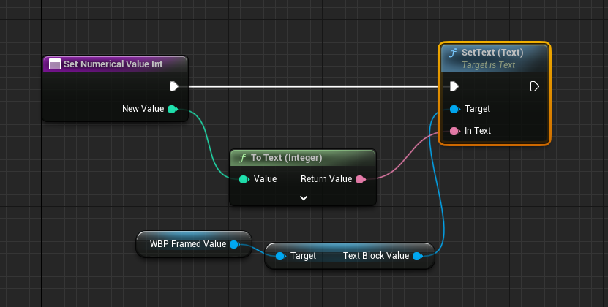

In textValueButtonRow:

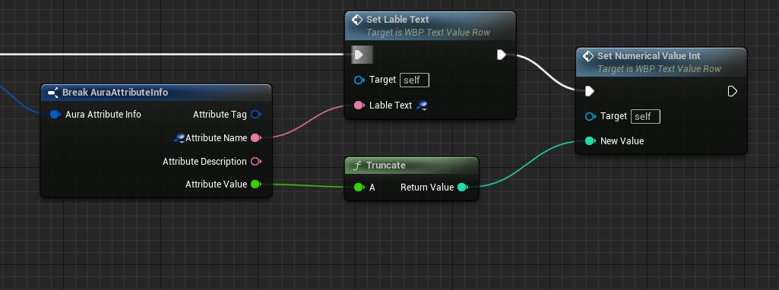

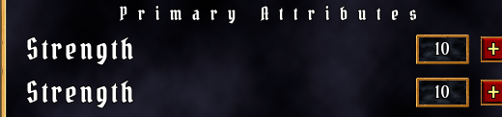

Now we see the text and values.

Nb secondary are not using the same widget as primary (no buttons) so they still have default values